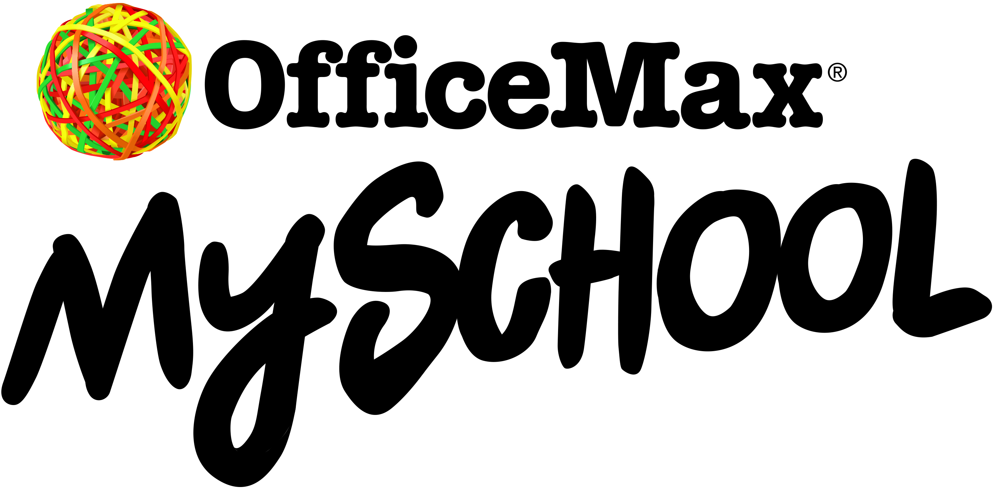

Thursday 24th November, 2016

Dear Parent / Guardian,

RE: 2017 SCHOOL STATIONERY ORDERING
– CREDIT/DEBIT CARD OR SECURE INTERNET BANKING ONLY

To make going Back to School easy for you, we have teamed up with OfficeMax MySchool to have our requirements lists loaded on to myschool.co.nz/tetotara
We’ve found this is the easiest way for you to purchase your child’s requirements. Simply search for our school, select your child's class/subject lists and follow the instructions on the website.

Buying through OfficeMax MySchool also earns School Rewards for our school which we can redeem for much needed educational supplies, equipment for our classrooms or for students in need. OfficeMax MySchool make Back to School easy for you with:

- Price Match Promise - find a lower price and OfficeMax will match it! Conditions apply, see myschool.co.nz for details.
- Free Delivery - for orders over $57.50 Plus, you can choose delivery to your home or workplace and receive your order during the holidays, straight to your door. See myschool.co.nz for delivery windows.
- Multiple ordering options - online at myschool.co.nz OR Freephone (0800) 724 440 OR in at the OfficeMax retail store located at cnr Victoria Street & Princes Street, Hamilton.
- Save valuable holiday time - avoid busy shopping malls and shop online from the comfort of your home.
- Quality product - your child will start the year with the correct supplies that will last.
- Multiple Payment options – including secure internet banking, credit/debit card or pay by cash in an OfficeMax retail store.

Please note: Student ID field NOT required, please leave this blank. If you have a new entrant child starting in Term 1, 2017 your child will be classified as a Year 1.

Note: All orders must be received prior to Thursday 26th January, 2017 to ensure delivery before school starts on Tuesday 31st January, 2017.
Please purchase your child’s stationery during the school holidays so that they have it on the first day of Term 1, 2017.

If you do not have access to the internet, you can purchase stationery direct through OfficeMax (cnr Victoria St & Princes St, Hamilton) Ph: (07) 838-8604. Please advise them that you are from Te Totara Primary School and the year level your child/ren will be in 2016. They will have hard copies of all our stationery lists available at the OfficeMax shop from Monday 7th December onwards.

Regards,

Brian Sheedy
Principal
INSTRUCTIONS FOR ORDERING STATIONERY:
Credit/Debit Card or Secure Internet Banking Only

- Type in myschool.co.nz/tetotara

- Enter your child’s First Name, Last Name and select the appropriate Year Level for 2017 from the drop-down box (do not enter any details under Student ID).

- A green box √ will appear, click on “View Requirements List” at the bottom right of the page.
This will bring up the stationery list for your child’s year level in 2017. All items showing on this screen are compulsory to purchase, unless indicated by a note applicable the item on the order screen.

- Scroll down to the bottom of the page and click on “shopping cart”.

- If you have another child at Te Totara Primary School and need to purchase stationery for them, click on “+ Add Another Student”, select “from the same school”, this will bring you back to the screen where you can enter your next child’s First Name, Last Name and Year Level for 2017 (do not enter any details under Student ID). A green box √ will appear, click on “View Requirements List” at the bottom right of the page.

- Click “checkout” then follow the instructions for payment and delivery details. Compulsory fields are indicated by an (*). Click “√ Confirm, next to payment details”. Complete Part 2 Payment Details, select method of payment as instructed, click “Complete & Make Payment”.

- If you do not have access to the internet or would prefer purchase your stationery directly from the OfficeMax shop, their details are: OfficeMax, cnr Victoria & Princes Street, Hamilton Ph: 838-8604. They will hold copies of our stationery lists; just advise them which Year Level your child/ren will be in 2017.

- These special “Back to School” prices on offer will be available through to the end of February 2017.

Please note:
All orders must be received prior to Thursday 26th January 2017 to ensure delivery is received before school starts on Tuesday 31st February, 2017.

