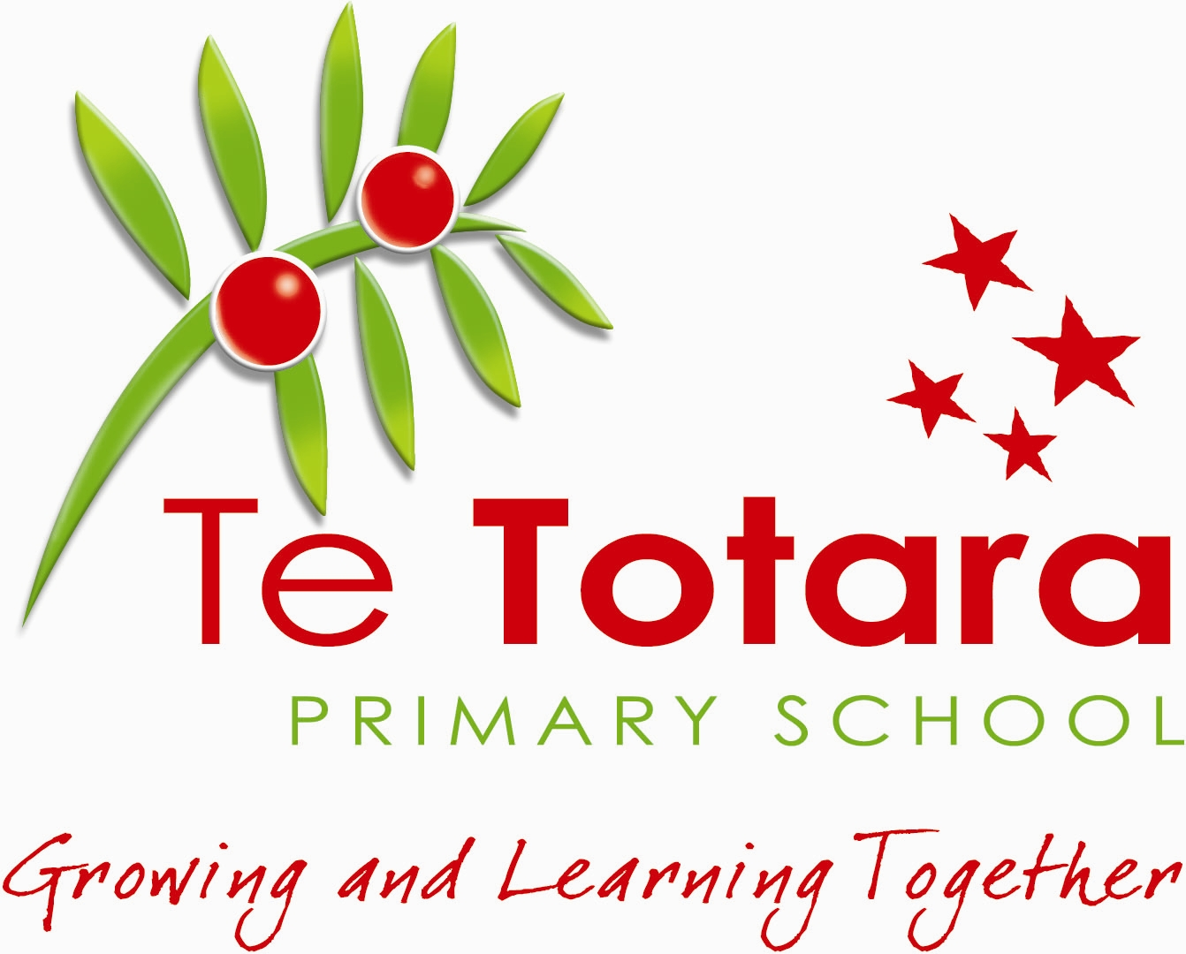
TE TOTARA
PRIMARY SCHOOL

POLICY: Social Media Policy

Why have this policy?
We recognise the importance of Te Totara Primary School teachers, staff, Board members, students and parents learning and carrying out relevant school-associated tasks by using social media applications. However, there are risks associated with this and there is scope for harmful behaviour to be communicated by or to students, staff, teachers, Board members and parents.

The aim of this policy is not to limit personal expression but to limit the direct or indirect damage that can be caused to members of our community or the school through inappropriate use of social media applications.

What is Social Media?
This refers to the creation, sharing and exchange of information and ideas through interactions that take place in virtual communities and networks, such as Facebook and Twitter.

How we do it?
We set standards of behaviour for the use of Social Media that are consistent with the values and expectations of Te Totara Primary School. The policy also aims to protect the safety and wellbeing of students, staff, teachers, Board members and parents by establishing expectations and specific guidelines that contain rights and responsibilities.

Expectations and Responses to Breaches of the Policy
There is an expectation that teachers, staff, Board members, students and parents will, when engaging in any social media application that relates to Te Totara Primary School:
- Respect personal and professional boundaries;
- Ensure that their on-line behaviour reflects the same standard as they would communicate face-to-face;
- Ensure content is accurate and not misleading;
- Think before they post; and
- Not post or respond to material that is offensive, obscene, threatening, bullying, harassing, discriminatory, hateful, threatening, violent, racist, sexist, pornographic, unlawful or may damage the reputation of the school.

In any instance where a teacher, staff member or Board member comes across material on a social media application that is offensive, obscene, threatening, bullying, harassing, discriminatory, hateful, threatening, violent, racist, sexist, pornographic, unlawful or may damage the reputation of the school, they are required to notify a member of the senior leadership team as soon as practicable. If that teacher, staff member or Board member is the author of the alleged breach of an above expectation or the Teacher, Staff and Board Guidelines, it will be considered by the senior leadership team or referred by the principal to the Board Chair for investigation and/or action. That action may include notification to the Police.

In any instance where a student comes across material on a social media application that is offensive, obscene, threatening, bullying, harassing, discriminatory, hateful, threatening, violent, racist, sexist, pornographic, unlawful or may damage the reputation of the school, they are required to notify a teacher or staff member immediately. If that student is considered to be the author of the alleged breach of an above expectation or the Student Guidelines, it should be considered under the Student Behaviour Management Policy or referred to a member of the Senior Leadership Team. Student sanctions may include loss of computer privileges, detention, suspension, or exclusion from Te Totara Primary School.

In any instance where a parent of a Te Totara Primary School student comes across material on a social media application that relates to the Te Totara Primary School and is offensive, obscene, threatening, bullying, harassing, discriminatory, hateful, threatening, violent, racist, sexist, pornographic, unlawful or may damage the reputation of the school, they should refer it to the Principal immediately. If that parent is considered to be the author of the alleged breach of an above expectation or the Parent Guidelines, it will be considered by the Principal, who will on a case-by-case basis deal with it or refer it to the Board Chair for action. Action may include notification to the Police.

Where it affects a Te Totara Primary School teacher, staff member, Board member, student or parent, a breach of any expectation or guideline may result in it being considered under criminal legislation aimed at addressing the harm caused. It includes is the Harmful Digital Communications Act 2015, threatening behaviour under the Summary Offences Act 1981 or Crimes Act 1961 and harassment under the Harassment Act 1997.

Teacher, Staff and Board Guidelines

Teachers, staff or Board members should not interact with students as “friends” on their own social networking sites;
- Teachers, staff, and Board members must not discuss or criticize Te Totara Primary School teachers, staff, Board members or parents or any Te Totara Primary School policies on any social networking site;
- While teachers may have been granted permission by student’s families to post photographs of students, they do not have permission to use photographs for a non-school use without seeking approval from a member of the senior leadership team;
- Teachers must regularly monitor students that have permission to access social networking sites;
- Teachers should not post confidential school information on any social networking site; and
- If teachers, staff or Board members identify themselves on a social media network as being associated with Te Totara Primary School they are taken to be representing the entire school community. They must therefore act consistent with the values of the school and resist doing anything that shows the school in a negative light.

Student Guidelines
- Students must seek permission from a teacher before accessing any social media site at School; and
- Students must allow access to any teacher that wishes to monitor access to a social networking site;

Parent Guidelines
- Parents are responsible for monitoring any access of any Te Totara children to social media networks outside of school. If a parent decides to allow their children access to social media networks then it is recommended that an adult closely monitors that access to ensure there is no breach of any stated expectation in this Policy; and
- Parents must not criticize Te Totara Primary School, any teacher, staff member, Board member, student or other parent where it relates to Te Totara Primary School; and
- Parents must not post on any social networking site any confidential information about Te Totara Primary School, any teacher, staff member, Board member, student or other parent where it has any relationship to Te Totara Primary School;

Conclusion

- Teachers staff members, Board members, students and parents need to be mindful of the harm that can be caused by posts about anything connected with Te Totara Primary School. Once a post is uploaded, it is difficult to undo the damage caused. As a result, there is a risk of significant harm being done to the target of an author’s frustration and caution is therefore recommended. The Complaints Policy outlined avenues of redress for student related concerns.

BOT Chair …………………………..... Principal ………………………….....

Date Ratified: 28 March 2019 Review Date: March 2020

