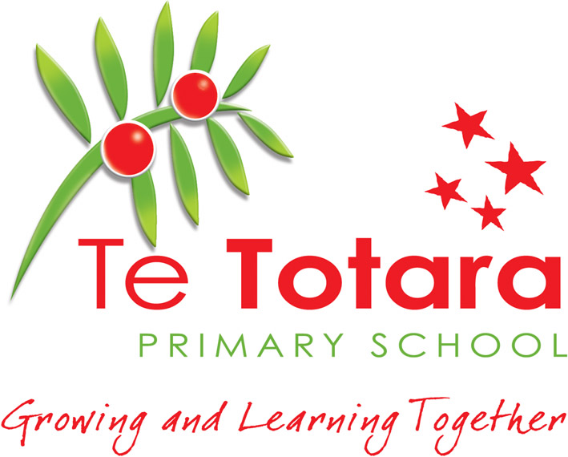

Report On Student Achievement

and

Aggregation: Term 1, 2014

Conceptual Strand : Identity, Culture and Organisation

- Students learn about society and communities and how they function. They also learn about the diverse cultures and identities of people within those communities and about the effects of these on the participation of groups and individuals. They learn that we are all citizens of a global and connected world which brings rights, privileges, responsibilities and challenges to develop a safe environment for all

- Teachers should keep in mind five key questions when planning these units of learning

  - How is this unit significant learning for these students?
  - What are the big understandings that the unit is based on?
  - What values and key competencies can be focused on?
  - How will I know that the learning has taken place and to what curriculum level?
  - What are the next learning steps for each student that needs to be developed?

Main Ideas Contained At Each Level Within the
Conceptual Strands:

Level 1 Context studied:  “Kotahitanga – We Belong ” | Level 2 Context studied:  “Citizenship”
The ‘ Big Ideas’ in the unit:  - Social Organisation  Understand how belonging to groups is important for people  Understand that people have different roles and responsibilities as part of their participation in groups.  - Digital Literacy / Citizenship  Begin to understand that they are a citizen of world (digital and real)  We are global children because we live in the world.  We are digital children because we use digital devices  Identify the use of, and who is responsible for the digital resources in the class (e.g. iPads, TV, computer)  Understand and use the protocols around iPad use  Understand and use the school protocols around taking and displaying a photo | The ‘ Big Ideas’ in the unit:  - Social Organisation  Understand how belonging to groups is important to people.  Understand how people have different roles and responsibilities as part of their participation in groups. (Level 1)  Understand that people have social, cultural, and economic roles, rights and responsibilities  (Level 2)  CONTEXT or SCENARIO:  We belong…Students are coming together to form a family unit and contribute to both the classroom and school community where differences can be acknowledged, valued, and celebrated.  We belong…as New Zealanders. We may have different backgrounds, cultures or belief systems but have the same rights and responsibilities.  Taking these factors of how we belong to multiple groups how can we use our understanding of rules and responsibilities to form a safe environment as ‘Digital Citizens’

Level 3 Context studied: ‘Citizenship’

BIG IDEAS:
Citizenship has formal rights and duties
Citizenship as an identity and a set of moral and social rights
Citizenship is a public practice with legal and political processes
We are globally connected
We live in an interconnected and interdependent world
We need to make decisions about how we participate in global communities
Citizenship is participation in decision making in all aspects of life
Rapid changes in technology allow quicker and more effective communications around the world
Changes in global communications technology create opportunities and challenges
Digital citizenship is about treating others the way we would like to be treated
Digital citizenship is about a way of being in the digital world.

LEARNING OUTCOMES:
There are different ways people can become New Zealand citizens
New Zealand citizenship has particular rights and responsibilities
New Zealand citizenship laws have changed over time
People from any country can apply to become New Zealand citizens and do so for different reasons
Develop rights and responsibilities for being a citizen in the digital world
Treat others the way we would want to be treated

Values- Throughout the unit the following values from The New Zealand Curriculum will be modelled, encouraged and explored.
- Respect for themselves and others
- Equity, through fairness and social justice
- Curiosity by thinking reflectively and critically about an issue
- Community and Participation for the common good of a society
- Integrity, which involves being honest, responsible, accountable and acting fairly

Key Competencies- Throughout the activities in this unit, there are many opportunities to develop the key competencies identified in The New Zealand Curriculum. In particular, this focus of learning develops the key competencies of:

- Relating to Others Te Totara Reach for the Stars
- Participating and Contributing Always Learning and Respectful
- Using Language, Symbols and Text Smart Decisions and Self Managing

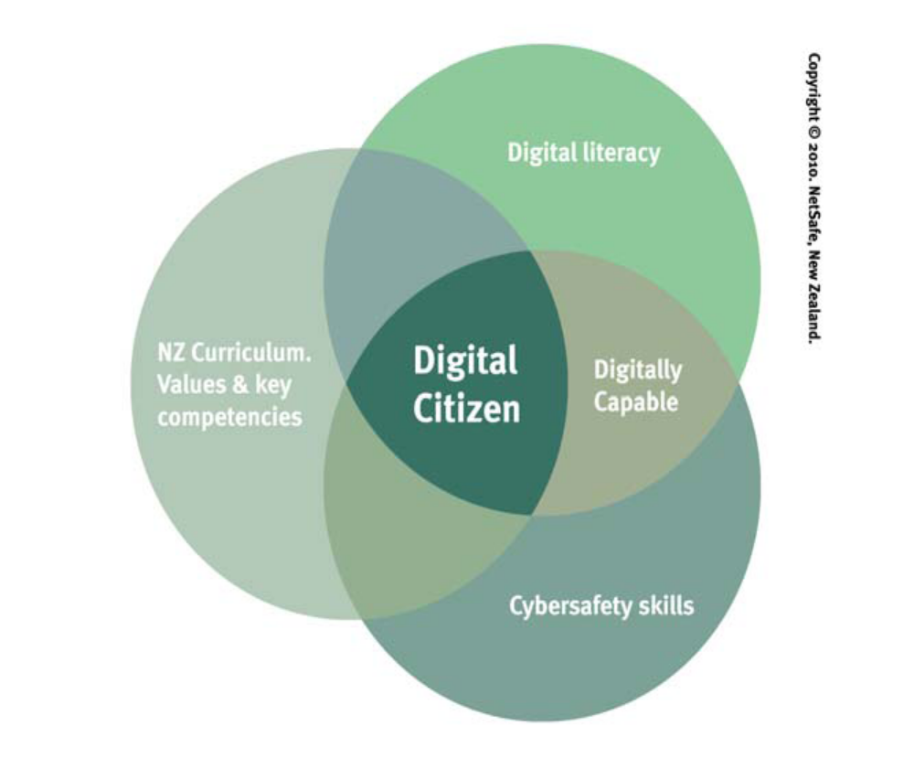

Social Science  The New  Zealand  Curriculum  ( 2007)  Students will gain knowledge, skills and experiences to:  Conceptual Strands | Level One  Programme | Level Two  Programme | Level Three  Programme
Identity, Culture  and Organisation | - Understand how belonging to groups is important for people  - Understand that people have different roles and responsibilities as part of their participation in groups  - Understand how the cultures of people in N.Z. are expressed in their daily lives | - Understand that people have social, cultural and economic rights and responsibilities  - Understand how cultural practices reflect and express people’s customs, traditions and values  - Understand how the status of Maori as tangata whenua is significant for communities in N.Z. | - Understand how groups make and implement rules and laws  - Understand how cultural practices vary but reflect similar purposes  - Understand how the movement of people affects cultural diversity and interaction in N.Z.
Place and Environment | - Understand how places in N.Z. are significant for individuals and groups | - Understand how places influence people and people influence places | - Understand how people view and use places differently
Continuity and Change | - Understand how the past is important to people | - Understand how time and change affects people’s lives  - Understand how people make significant contributions to N.Z. society | - Understand how people remember and record the past in different ways
The Economic World | -------- | - Understand how people make choices to meet their needs and wants | - Understand how people make decisions about access to and use of resources

Achievement Objectives At Each Level

(Technology in the NZ Curriculum)
______________________________________________________

Level One and Two (generally Years 0 – 2, and Years 3 - 4 students)

Level Three (generally Years 5 and 6 students)

The students will be able to:
Strand | Level One and Two Programme  Technology  The New Zealand  Curriculum  ( 2007) | Level Three Programme  Technology  The New Zealand  Curriculum  ( 2007)
Nature of Technology  Students will: | Characteristics of technology  Understand that technology is purposeful intervention through design (Level 1)  Understand that technology both reflects & changes society & the environment & increases people’s capacity. (Level 2)  Characteristics of technological outcomes  Understand that technological outcomes are products or systems developed by people & have a physical nature and a functional nature (Level 1)  Understand that technological outcomes are developed through technological practice & have related physical & functional natures  (Level 2) | Characteristics of technology  Understand how society & environments impact on & are influenced by technology in historical & contemporary contexts & that technological knowledge is validated by successful function  Characteristics of technological outcomes  Understand that technological outcomes are recognisable as fit for purpose by the relationship between their physical and functional natures

TABLE OF STUDENT PROGRESS WITHIN THIS STRAND – April 2014

Achievement  Level: | Early Level  1 | Secure Level 1 | Level 2 | Level 3 | Level 4

Class Level - Numbers of Students working at each level.

Year 1  (129 students) | 73 | 56
Year 2  (141 students) | 2 | 137 | 2
Year 3  (113 students) | 1 | 23 | 89
Year 4  (125 students) |  | 1 | 124
Year 5  (95 students) |  |  | 23 | 72
Year 6  (80 students) |  |  | 5 | 68 | 7

ANALYSIS AND RECOMMENDATIONS

All Students :

Number of students assessed across Year 1 - 6 683 students.

From the data above the majority of all year levels is either at or above
the Achievement Band Expectation.
(674 students at or above expectation Curriculum levels)

Overall throughout the school we have 98.6 % of the students working at or above the
Achievement band expectation. This is an excellent result.

Male Students (Total:336)
From the data above the majority of all year levels is at or above the Achievement Band Expectation.
(329 male students at expectation Curriculum levels)

Overall throughout the school we have 97.9 % of the male students working at the
Achievement band expectation.

Female Students (Total: 347)
From the data above the majority of all year levels is at or above the Achievement Band Expectation.
(345 female students at expectation Curriculum levels)

Overall throughout the school we have 99.4 % of the female students working at the
Achievement band expectation.

Students not achieving at expectation levels – 9 students

Of these 9 students, 3 are ‘English as a Second Language’ students, so are often at a lower stage of development with literacy oral/written language development. Of these 9 students achieving below expectation levels, 7 of them feature in our Learning Support roll, with literacy delays.

Maori and Pasifika Students:

Number of Maori students (86) and Pasifika students (6) assessed across Year 1-6

92 students

Of these students 89 are either at or above the Achievement Band Expectation.
- Maori Students - 83 out of the 86 are at expectation levels, which is a result of 96.5% of Maori students at expectation level.
- Pasifika Students – All 6 students are at expectation levels, which is a result of 100% at our expectation level.

For our Maori students and Pasifika students this is a result of 96.7 % working at or above the Achievement band expectation. This is also an excellent result.

What went well with this unit of learning

This unit of work began with staff Professional Development, on our January 2014 ‘Teacher Only’ day, about the concept of Digital Citizenship.
The presentation that was shared to our staff was developed from information sessions attended at the U Learn conference in October 2013 and resources from Netsafe website.

This professional development was targeted at growing the staff’s own knowledge of the ‘Digital World’, the strengths and issues of being a ‘citizen’ in that world. One of the suggestions was to ‘Google Yourself’ to see what their own digital footprint looked like. Examples of digital footprints and digital dossiers were explored as well as some of the impacts of social media.
For many of our teachers the session was an ‘eye opener’ in terms of the long term power of the digital world, the positive and negative effects of online presence within this world.

Mentoring students to become digital citizens includes addressing issues of respect and identity, access and Internet safety. It starts with the Digital teacher.

In terms of unpacking the learning in Term 1 the unit worked very well, originating in our Health units focusing on our STAR values, at the start of the year around belonging to and building a positive classroom community, as Te Totara citizens.

To flow onto the idea of a wider community, belonging through citizenship and then to digital citizenship it was felt that an understanding needed to be developed around four key concept questions:

- What is ‘Belonging’ and how do we do this (class, school, home, community)?
- What is ‘Citizenship’, who does this include, how and why?
- What is ‘Privileges’ and how is this expressed in a community?
- What is ‘Responsibilities’ and how is this expressed in a community?

The authentic scenario for the citizenship in a digital community unit was to develop a student created presentation across the school which was suitable for inclusion in the E Learning section on the Te Totara website and also linked from the Te Totara Facebook page on Digital Citizenship.
This gave real purpose to the topic. In one of our senior areas the teachers have been involved in starting up class blogs. Through this process they gained an understanding of how important it is to be aware of others, when communicating online.
They also realized that they have a role to play when using any digital device and we can all use our ‘Reach for the Stars’ to guide us with this.

A number of staff members shared that when the students explored ‘belonging to groups’ and ‘citizenship’ they realized there were parallels to becoming and being a positive contributing citizen to being a digital citizen – only the digital world is often ‘unpoliced’ and more up to the individual user to monitor how productive they are when communicating in cyberspace or using digital devices.

In our junior rooms the teachers commented that the highlight for the students was making the videos on the iPad about how to care for the iPads. It helped to have a ‘real’ purpose and the videos are being used to make a movie for the new junior children. Also since making the movies teachers have said that the children are looking after the iPads a whole lot better so it was really meaningful learning.

The involvement of families in our community in discussions with their children around the use of digital devices, family rules and privileges through Home Learning tasks and interview questions was a strong aspect which helped to strengthen our school community understanding. The website presentations will be a great community link with regard to this learning.

The use of student self-assessment around specific criteria and outcomes, to respond to and express their own learning, was an effective way to gauge student explorations in the areas of developing values and the key competencies

Curriculum integration occurred with the essential learning areas of Social Science, Health
and Physical Education; Personal Identity, Relationships with other People and Healthy
Communities, English (Oral – group discussion dynamics, Written – Script and report
Writing, Visual - Effective Presentation) Digital Technology through the creating of a
technological outcome as described :

Students will.
- Plan a pamphlet, slide show or short role play using digital devices, which communicates their understandings about ‘Citizenship in a Technological environment’ including their roles and responsibilities.
- Incorporate features of a pamphlet such as titles, gutter, photos and captions, speech bubbles.

Planning
- Display some expertise in either ‘powerpoint’, ‘Comic Life’, or on the iPad to create a pamphlet or visual presentation
- Create a pamphlet or presentation which meets the specifications set by the group
Evaluate and modify the final product.

At the conclusion of this unit, Technology use can be extended to apply to other Curriculum areas for presentation and learning – teachers are encouraged to look into other unit planning to consolidate and reinforce the skills developed. This has occurred in some of our subsequent Term 2 units.

Ideas for Future Action of this or a similar unit - Linked to our future Strategic Planning.

- All the scaffolding and teaching about needs to happen before the students get to the age when they are highly active in the online world.
They become ‘independent users very quickly’ – we need to mentor them ahead of that time so their digital behaviours become’ learned.’ Just as we do through our STARS programme.
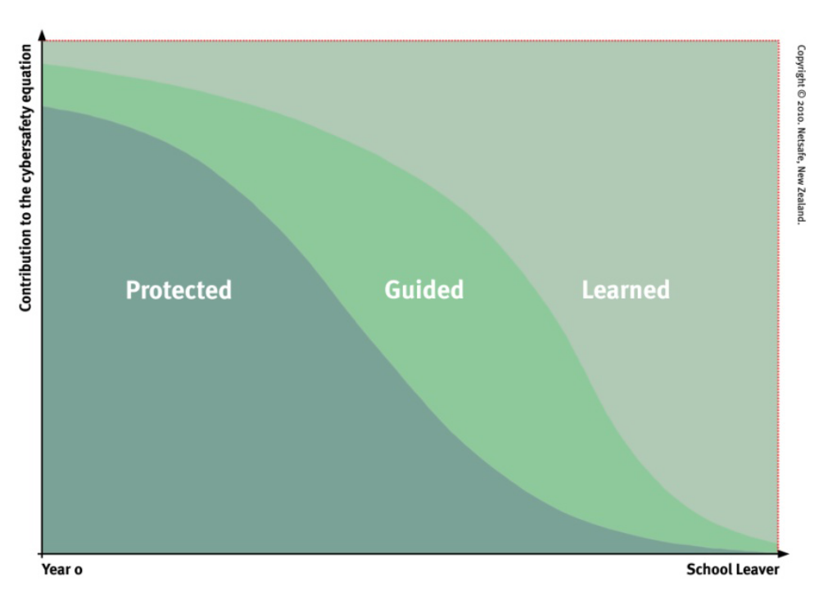
Protected and Guided part of graph diagram is for primary and intermediate stage.
Our Curriculum talks about creating Confident, Connected, and Collaborative Learners. We can use the Key Competencies to help teach our students in this area. For Te Totara we think about the power of our Reach for the Stars programme.

- Continue School development in the E learning area. Vision, strategic intent, protocols to model and demonstrate digital citizenship, BYOD protocol development and decisions around the management of our Apps and devices.

We are on this journey already but we still have much to implement…

- Vision and values, culture of readiness, community links.

2. Ongoing development of teacher and learner pedagogy.

3. Infrastructure – safe and secure

4. Safe and responsible use policies
• Rules of engagement
• Acceptable use agreements (Internet, Mobile)
- Teachers Council resources about being safe online as staff.

- Continue to foster E learning professional development with the staff through authentic Curriculum contexts. Have a school-wide expectation of the use of E learning, not just as skills based app practice but in a way to research, create, present and extend learning.
- Explore questioning skills as part of the literacy and general class programming. Encourage students to reflect on their learning by using graphic organisers in the senior school to support this. On-going use of digital citizenship outcomes such as the Oath or Digital STAR language to guide students when using digital devices, link this in with school expectations and our Reach for the Stars guidelines.

- Our New Entrant teachers found the digital citizenship part of the Kotahitanga / welcome to school topic quite a challenging unit to work with as the understanding of the digital device and the online world was quite abstract. In order to make some things into the ‘known and understood’ lots of experiences and reflections are needed in that area. The objective would be when children have been at school for 6 months and experienced digital devices doing many things they are better able to reflect and draw on those experiences with understanding.

It is important to remember to explore with the children why we do things (e.g. why do we ask if we can take a photo?) to foster good understanding not that we just do it as an expectation or a school rule, with no developed ‘digital/moral compass.’

Putting together a portfolio of valuable experiences (‘Discovery time’) to have with the
children, along with vocabulary we are encouraging over a year would be a more
logical ‘immersion’ into Digital Citizenship to be built on in later years e.g. give them
some of the experiences, procedures and language to be built on later.

- The online safety aspects of Digital Citizenship will be further reinforced by our regular Health unit every second year on ‘Keeping Ourselves Safe’ which we are committed to in conjunction with our Police Educators.

- We continue to target resource purchases in the Social Science Learning Area towards the specific teaching and learning contexts selected within the teaching year (i.e. 2014 ‘Big Ideas or Rich Concepts) as we build up a bank of successful teaching resources. E learning opportunities are an important component of effective research and presentation curriculum development.

- Continue to explore one school-wide focus each year in Social Science to build teacher knowledge in the Social Science Learning Area as staff professional development. Curriculum knowledge of concepts and units need to be shared to ensure that we have a common understanding of the levels of the curriculum, where our expectations for student learning are and where the students are currently achieving at. The other Social Science units during the year can be at the team or class level in response to the needs of the students. The Curriculum Manager is to closely monitor planning and teaching in this curriculum area.

- E.S.O. L. students need to continue to receive specific curriculum and vocabulary support from our E.S.O.L. teacher to maximize their learning opportunities in this learning area. They are often quite adept on digital devices however literacy development can be a barrier to effective communication in this area therefore teacher scaffolding and peer support is vital.

- Being part of a global community is a concept that is often a difficult one to develop with children however I believe the way that we developed this unit using the ‘Big Ideas’ using the Key Competencies was the most beneficial way to proceed.
With our younger students we moved from the most visible and immediate observations of the groups they belong to and communicate with, to exploring, with our older students, the more challenging concepts of ‘belonging as a citizen’ with rights or privileges, and responsibilities.
This progression developed an awareness and understanding of social responsibility,
respect and a ‘moral compass’ for our students.

This document on student achievement in Science - Term 1 2014 was reported to the Board of Trustees Meeting on 26 June 2014.

The valuable input of all staff is acknowledged in the preparation of this report.

Anne Fraser
(Deputy Principal / Curriculum Manager)

