An analysis of Te Totara Primary School community views on the future direction of the School

**Te Totara Primary School Charter Consultation 2015**

Produced by the Te Totara Primary School Board of Trustees 2016

**Contents**

Background of Te Totara primary School

What is a Charter?

Why review our Charter

Term of the Charter

Consultation undertaken

Findings

Recommendations for 2016 Charter and Annual planning

**Background of Te Totara Primary School**

Te Totara primary School is located in the north east of Hamilton city. It opened for learning in 2008 with 58 students. Since this time it has experienced rapid growth and by the end of the 2015 school year had grown to a roll of 819 students.

The school during this time has had the benefit of committed and highly capable School Governance through the Establishment Board of Trustees, followed by three parent elected board of trustees. In addition the school has experienced stable leadership, with the current principal, deputy principal and assistant principal being foundation staff members.



The school has had a strong focus on values as a way of being, these are referred to as the “STARS” and a galactic theme has been used to support Teaching and Learning programmes, building names and a school ethos.

During this time of growth the School has had significant growth in the demographics of the community, this has seen the school have over 30 different countries of origin for families. This has been especially so from 2011 onwards.

The school has modern and attractive learning environments provided by the Government with three stages of construction. Successive Board of Trustees have enhanced facilities with the provision of a swimming pool, changing sheds, air conditioning for all rooms, court areas, irrigated fields and enhanced office space.

Since the beginning of the school in 2008, there has been a strong commitment to providing the best possible resources for Students, through the employment and support for high quality personnel, teaching and learning programmes as well as high levels of student achievement across the new Zealand Curriculum.

**What is a Charter?**

The Education Act 1989 requires every school to complete a charter and a copy of the annual charter update to be sent to the Ministry of Education each year.

It is an agreement between the Ministry of Education and the School to provide high quality education for students and the community.

The role of the board is to prepare and maintain the school charter.

Annual charter updates are required to be submitted to the Ministry by 1 March each year. The charter is a key planning document that sets out the school's objectives and targets for the year, it is important it is in place at the start of the school year. It can then be effective in setting teaching and learning programmes and guiding the activities of your school.

**Why review our Charter?**

A charter is a living document as it needs to reflect the need and aspirations of the community it serves as well as priorities stipulated by the Government.

At Te Totara Primary School there has been a cycle of a major Charter review and direction setting every three years, this is to ensure that the Charter remains current and fit for purpose.

All stakeholders are involved in ongoing review, including Students, parents, wider community, Maori community and Board of Trustees.

The School undertakes ongoing review and improvements and these are detailed in an annual plan. This plan supports the direction of the School in its everyday working life of the and support student achievement.

**Term of the Charter**

The term and timeframe of the Charter is from 2016-2019. This timeframe is very deliberately set as it follows the natural cycle of a three yearly elected Board of Trustees. In 2016 there will be a newly elected Board of Trustees.

An updated charter allows them to have a recent and up to date plan in consultation with the community to support them in their Governance role. It provides continuity, yet allows for decision making by the Board based on up to date information.

The next planned full charter consultation is due on 2018, however an ongoing programme of self-review through the annually updated school plan allows for proactive planning and implementation based on any emerging needs of the School and Government priorities.

**Consultation undertaken**

**Timeframe**

The Board of Trustees began this process in May 2015 with a timeline of action to be completed for the a draft to be prepared for consideration at the January 2016 meeting before final sign off to the Ministry of Education by 1 March 2016, to ensure that all compliance matters set by the Ministry of education were completed.

**Who was consulted and how?**

That the consultation had to be inclusive and involve a range of ways of consulting to be undertaken, this included:

* Confidential on line survey for parents with the following questions

|  |
| --- |
| Do you think the School's Aim and Purpose(shown above) fits our School? |
| Is there anything else you would like included? |
| How can we better cater for your cultural needs? |
| What cultural aspects do we do well? |
| What would you like to see us do next in this area? |
| What aspects of our School do you think we do well? |

* Surveying parents at the School Cross country
* Meeting with Whanau and Maori community. Oral discussions and opportunity for using sticky notes so confidentiality was maintained
* Students voice through the student council and presentation to Principal and PTA of ideas for the school
* Staff through questionnaire of what we do well and what we can do next and how that will help
* PTA discussion,
* Two public meetings
* Consulting with Early Childhood centres by Principal visiting and listening to feedback form prospective parents of the School
* Discussion with Rototuna Junior High School Leadership school due to open in 2016

**Findings**

Parent online confidential survey

A total of 103 responses were made by parents:

|  |  |
| --- | --- |
| **Question** | **Responses** |
| Do you think the School's Aim and Purpose(shown above) fits our School? | 101/103 or 98% responses indicated that the School s aims as outlined fits our School, |
| Is there anything else you would like included? | 8 responded on this question, related to need to cater for gifted students, prayer room, outdoor education provision, celebrating values, self-managing of students |
| How can we better cater for your cultural needs? | Celebrate different cultures , acknowledgement of new signage, cultural days, food, music, Kapa Haka, marae visits, one lesson a week for Te reo, celebrate different events, i.e Chinese New Year |
| What cultural aspects do we do well? | 57% noted the School did well with cultural aspects, this included Marae, flags in Matariki “You acknowledge all cultures at school” “Continue to build great relationships” |
| What would you like to see us do next in this area? | Pronunciation of names  Sharing the story/knowledge of ethnic traditional days/festivals with all kids so they can enjoy the day. My point is sharing/mixing multiple cultures into one diversity NZ culture  More use of te Reo.  Keep up the awesome work  Expand to other cultural awareness & tradition |
| What aspects of our School do you think we do well? | 92% of respondents identified positive features of the School. This included STARS theme, communication, swimming, positivity, newsletters, staff and teachers, like the Year 1 format, relationships “Doing a good job of making a big school not feel so big, delivering on the STARS values and being open to new ideas” “Coverage of the learning areas and key competencies of The New Zealand Curriculum” Positive happy inclusive feeling” School Leade4rship |
| What do our students need to be successful in the future? | Common theme of the STARS, character, respect, celebrate success, technology, confident, transition programme for Year 6 students, knowledge of the word, respect, think for themselves |
| Do you feel informed as to your child's progression at School? | Overwhelmingly yes, with 94% of respondents feeling well informed or not concerned about this. 6% respondents said no, common them around keeping parents up to date, varied opinion on the learning plan, some too detailed and reliant on tests and others feeling very informed |

Survey at Cross country

This consultation took the form of our Student leaders walking amongst the parents who attended and asking them to fill out a survey, this provided a good cross section of responses, which were collated and provided the following:

Whanau hui and consultation with Maori

This consultation took the form of an evening with our Kapa Haka group and sharing of kai, with consultation being informal through discussions and an opportunity to put comments on sheets, allowing a much more relaxed style of consultation. Discussions with Whanau were very affirming regarding the direction of the school and the opportunities for children, and included some positive ideas going forward for the School

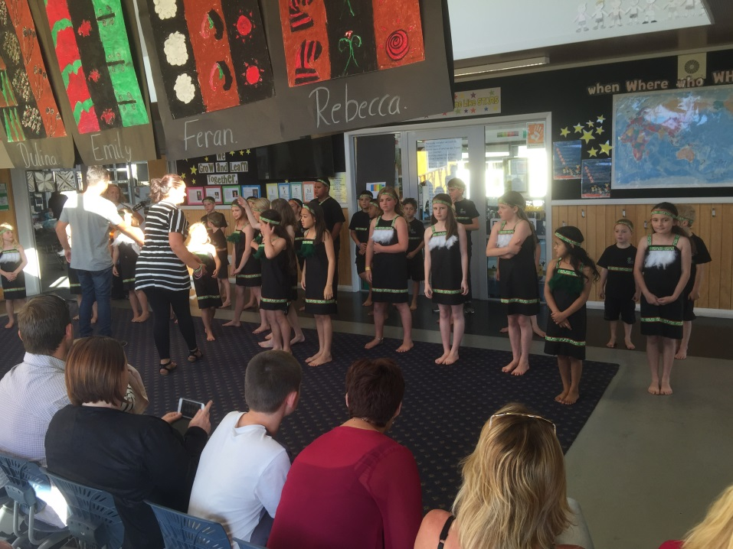

Kapa Haka performing at consultation meeting

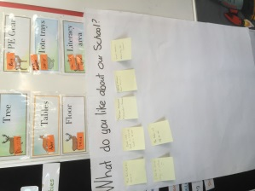

Aspects of our School that go well…

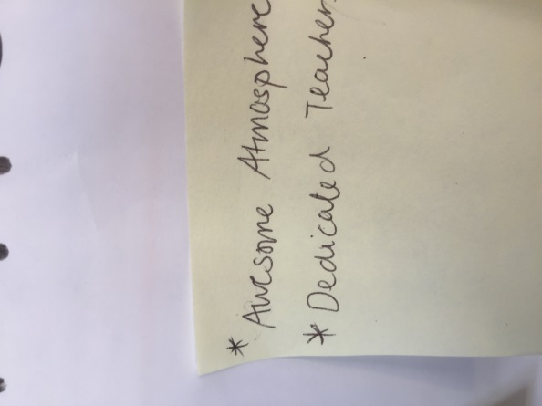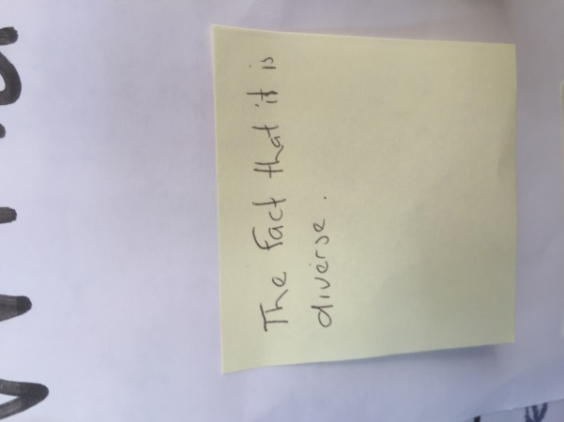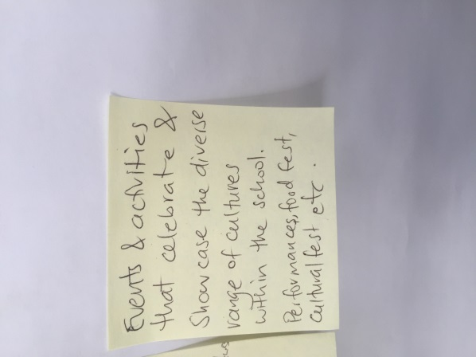

What other things could we do…

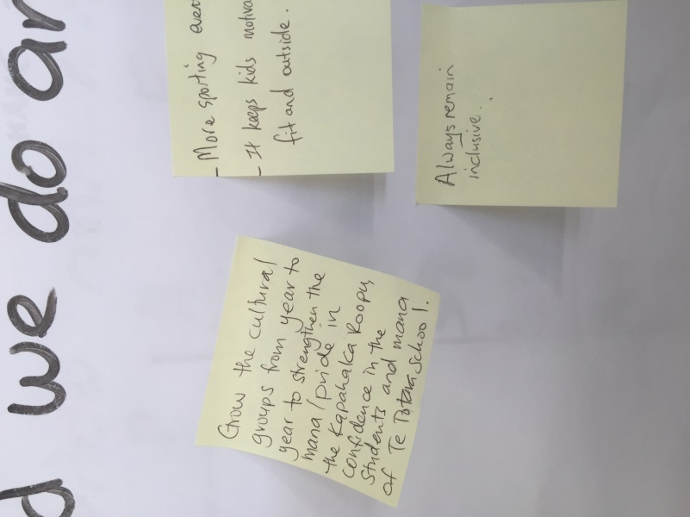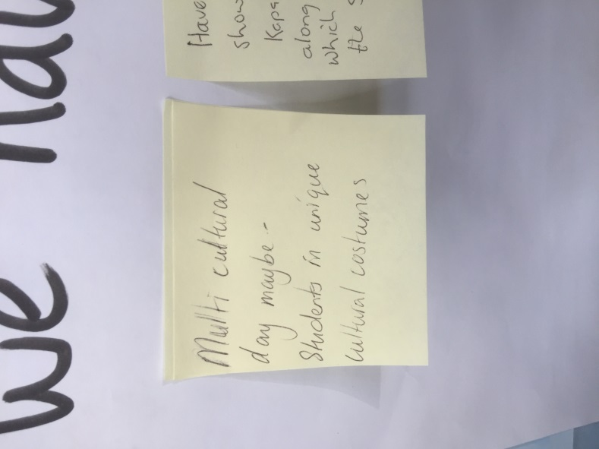

Also raised was around equity for the use of iPads in the School given the cost.

Students

The school has a student council that represents students and ideas that they might have for their school. The student council has dedicated boxes in the shared learning areas of each team for suggestions for the school which the student council consider. These are considered alongside the teacher in charge.

A major area that students tend to focus on is the items that make an immediate difference to them, a real focus from students about what they wanted for their school included:

* Rugby and Soccer posts
* Hand driers and mirrors in toilets
* Sports equipment

To support the students we did arrange a meeting with them and the PTA where children out forward these ideas via a presentation, this culminated in the PTA supporting the idea of Rugby and Soccer posts in the school, with a $5 000 donation to the school.

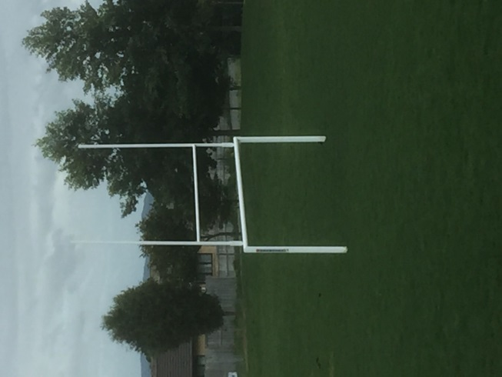After considering hand driers it was resolved not to proceed due to hand towels being a more healthy option. Mirrors are being installed in older students toilets.

Student voice made this happen...

Monitoring of student feedback on what they wanted for their school saw no obvious items or concerns raised by students and that as a student body are happy with their school.

Staff

Staff were consulted about the things they liked about their school and what we could do to improve what we do.

Overwhelmingly positive affirmation for school direction from the survey, including

* The STARS
* Professional Development
* Variety of out of classroom activities
* Structure and routines
* Communication, especially 10.55 meeting each day
* Quality of the staff
* Support for staff employers
* *“soooo many things.  Children are at the heart of all we do and I think that is something pretty spectacular.  Teams work well and collaboration is high.  The staff are more than just colleagues.  In many ways, we are family and genuinely care about each other.  We are well resourced.  We have some amazing classroom practitioners who run innovative programmes.”*

To consider:

* Revising learning plans and time taken
* Continue to celebrate diversity

PTA discussions

The PTA, who meet twice a term, are kept up to date with events at school and discussions with the Principal occur at these forums, consultation was discussed and opportunity through parent survey was encouraged. Many queries are able to answer in this more informal forum. A key feature of discussions is to continue to liaise together. As a result a t the end of 2015 it was agreed that the BOT and PTA would work together to undertake major fundraising for a covered court area for the school. A further illustration of the goodwill between the school and community.

Two Public meetings

Before these meetings were held the school initiated conversations with key members of the Indian, Chinese, Korean and Middle Eastern families. This was very beneficial and useful in preparing the way to meet with families. This resulted in two public meetings. These meetings were well advertised, they provided a wonderful opportunity to talk with families in a more familiar setting of the staff lounge, where Board members and families were able to discuss the school. It is suggested that in the future small meetings would gain more traction in terms of consultation for families to contribute to the direction of their school. Key findings of thee meetings were:

* Values of the Stars are important
* Consider teaching of Mandarin
* Ensure that communication is continued, an example is to make the newsletter single column to ensure ease of reading on mobile devices. (this has already been actioned)

Early Childhood centres

Our two immediate Early learning Centres, Barnardos and Learning Links, were most accommodating in providing us time to meet with drop in parent sessions to liaise with the principal and the newly appointed leader of transition to school, Bridie Carr-Neill. Major themes from parents is that they wanted their children to be safe, taught well and that almost all of them had some understanding of the School STARS

Rototuna Junior High School consultation

A meeting was held with the Senior Leadership team form the Junior High School and this provided an opportunity to share practice of this school while they form their school to start in 2016. It is vital to maintain professional links with and the school will continue to pursue this for 2016 and beyond.

**Recommendations for 2016 Charter and Annual planning**

* That 98 % of respondents in a confidential survey agreed the School was fit for purpose and the broad direction of the School should be maintained
* Continue the direction of catering for diversity
* Continue to enhance and acknowledge our increasingly diverse community
* Maintain and enhance our communication with our community
* Continue STARS programme Continue the School direction of the values of the STARS as a way of being at Te Totara Primary School
* Communicate more with families on our Tikanga programme, Learning support, including catering for those with talents
* Continue contacts with families
* Form a Community committee to coordinate our contacts with community