2020-2023 Strategic and 2023 Annual Plan

Our Aim and Values
Growing and Learning Together

Our Purpose
For our school community to be:

- Smart Decision makers leading to individual excellence and positive reinforcement of oneself, the school culture and whole community

- Trying our Best to achieve success, grow and develop new skills, meet targets, and surpass expectations

- Always Learning and growing individual and team academic, professional, and social skills

- Respectful at all times of cultures, beliefs, and decisions within our school and wider community. Embrace cultural diversity and encourage the learning of Te Reo Maori and Tikanga

- Self-Managing and taking ownership for learning, motivating, and celebrating success

About Te Totara Primary School

- Located at 31 Hector Drive, in the fast-growing Rototuna suburb in Northeast of Hamilton, New Zealand

- Opened in January 2008 with 58 students, at December 2022 had 750 students

- Has 38 Learning areas, that includes two Satellite classes from Hamilton North Special School, an Administration area that includes resource area and offices, also a Multipurpose area containing a Hall and Staff Lounge

- Has an Individual Learning plan for each student and teacher to help them develop and fulfil our Mission of “Growing and Learning Together”.

- Has a diverse community, with over 35 different nationalities (using the Ministry of Education designations), making for a great school. This includes 37.3 % NZ European, 12.4 % Maori students, 1.5 % Pasifika, 14.8 % Chinese, 8.5 % Indian, 10.5 % African and 15.0 % other nationalities including ‘other European’.

- Has a supportive community who are active in the school through groups such as the School Board (who govern the school) Parent Teacher Association and Whanau.

- Is an active member of Te Pae Here, Kaahui Ako, a large Community of Learning situated in the North-Eastern area of Hamilton City.

- Strong links have been established with Ngati Wairere, through the cultural report commissioned prior to the opening of Te Totara School and as the stakehold. This report is evidenced within the ethos of the school and visibly linked through the names of the buildings and our Reach for the STAR’s programme. This is also reinforced through their stewardship of Te Pae Here, Kaahui Ako.

- As the school has grown strong relationships have also been fostered with Kirikiriroa Marae through the schoolwide visits to this urban marae every second year. This was instigated as a result of consultation with our Maori community who continue to reinforce the importance of this link. Our students have a rich bond to Kirikiriroa and in their pepeha refer to it as ‘my marae.’ Since the impact of Covid the availability of Kirikiriroa has been diminished so TTe Totara has fostered a new relationship with Aratia Community Marae and Fairfield College.

- Runs a Before and After School care programme catering for over 120 students daily.

- For further information visit www.tetotara.school.nz

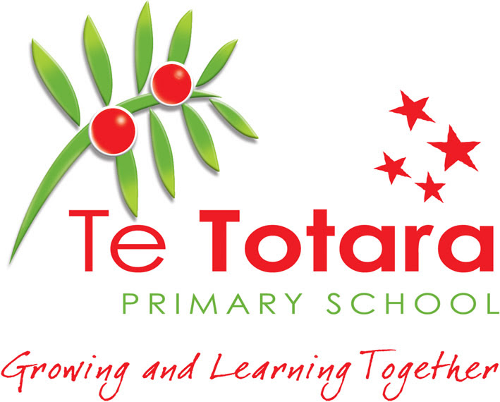

Strategic Plan 2020-2023
& Annual Plan 2023

Contents and Background

Pages 1-5 | Strategic Plan 2020-2023. This sets out the aims of the school over a four year period.
Pages 6-7 | Map of Action. This sets out when the plan will be implemented.
Pages 8-17 | Annual Plan 2023 Details the Actions, Responsibilities, Resourcing and Monitoring of the plan.
Pages 18-20 | Achievement Data 2022 Tables of year end data in Reading, Writing and Mathematics to inform 2023 Targets
Pages 21-22 | Specific targets to lift achievement in 2023. Details the targets we have set to lift achievement in Wellbeing
Pages 22-26 | Specific targets to lift achievement in 2023. Details the targets we have set to lift achievement in Reading,  Writing and Mathematics.

Principal’s Endorsement: | 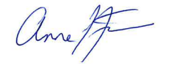  30/03/2023
School Board Presiding Member: | 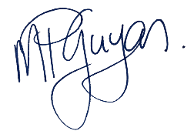  30/03/2023
Submission date to Ministry of Education: | 31/03/2023

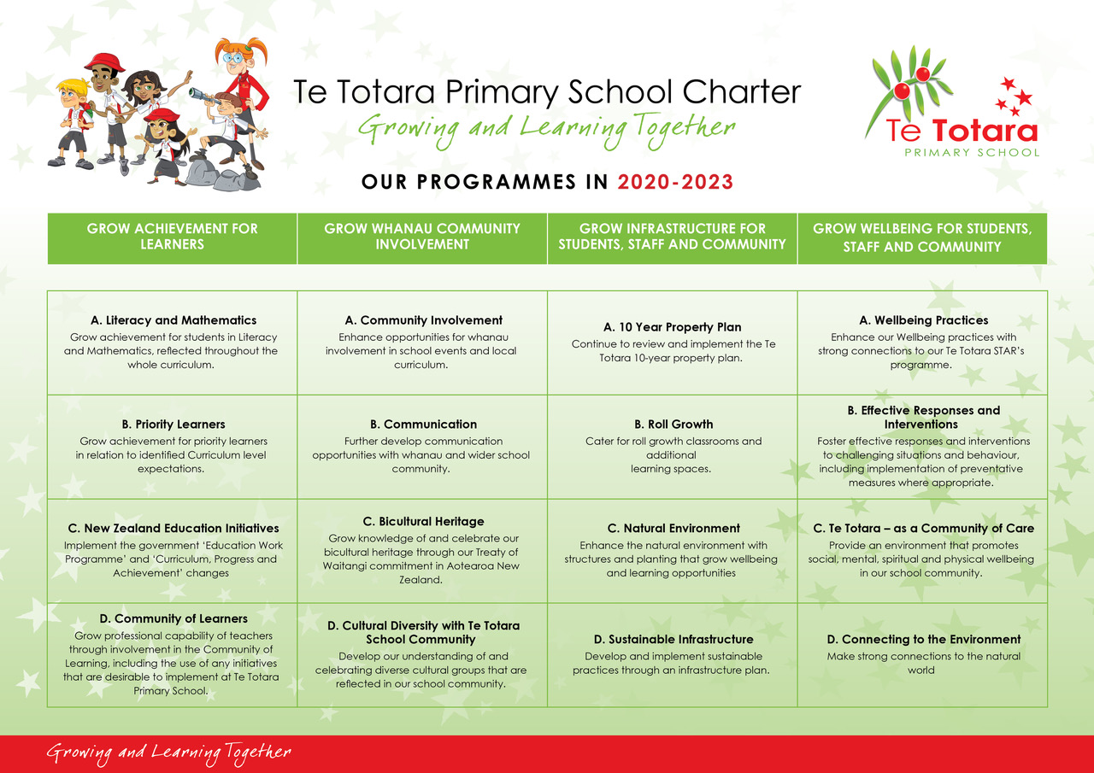
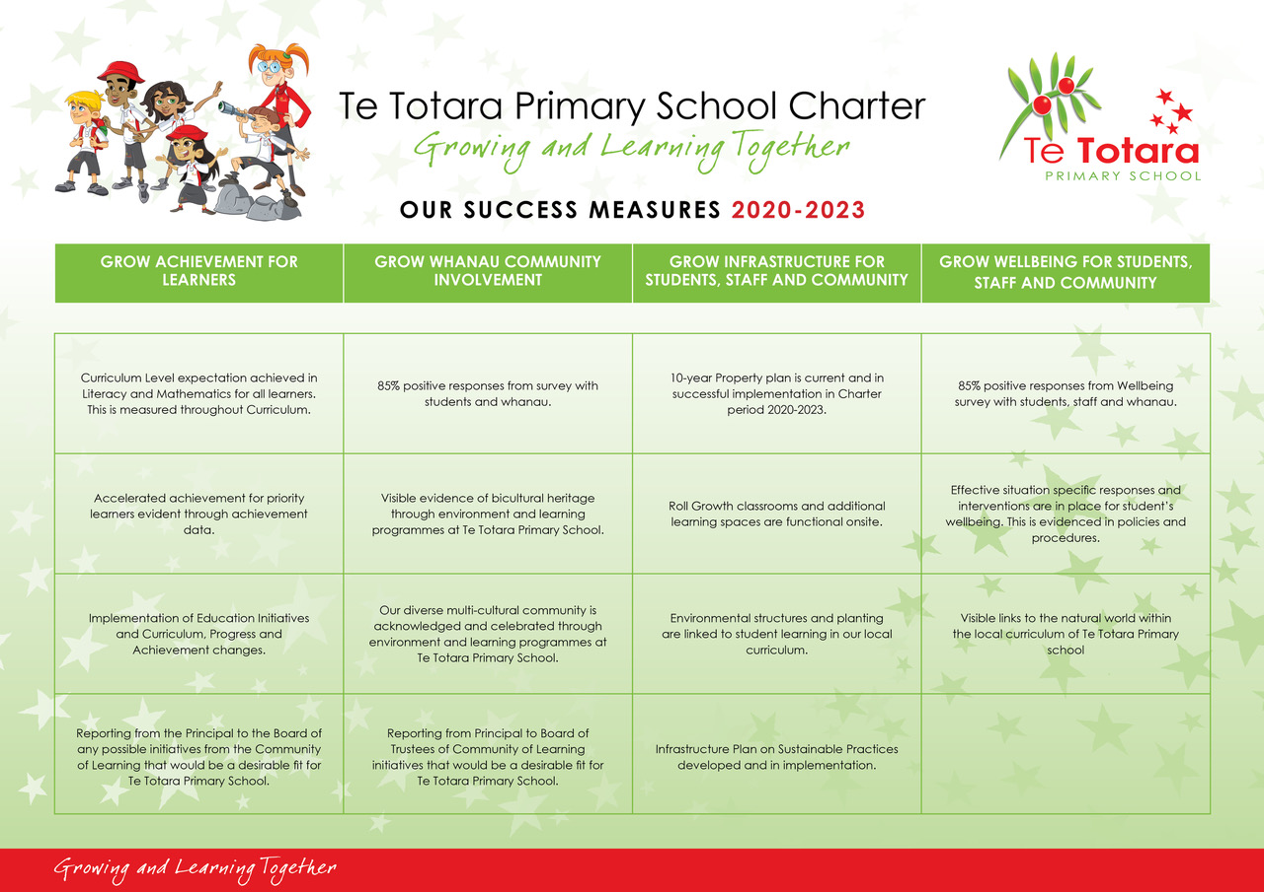

MAP OF ACTION
Grow Achievement  for Learners | 2022 | 2023
Literacy and
Mathematics
Priority Learners
New Zealand Education Initiatives
Community of Learners (Te Pae Here Kãhui Ako)
Grow Whanau Community involvement
Community Involvement
Communication
Bicultural Heritage
Cultural Diversity within Te Totara Community
Grow Infrastructure
10 Year Property Plan
Roll Growth
Natural Environment
Sustainable Infrastructure
Grow Wellbeing for Students, Staff and Community
Wellbeing Practises
Effective Responses and Interventions
A Community of Care
Connecting to the Environment

1.Grow Achievement for Learners; Priority and other Learners (N.E.L.P. Objectives 1:2, 2:3, 2:4, 3:5 and 3:6)

Action | Who RACI | How | Resourcing | When | Evidence of Success
A. Literacy and Mathematics  Curriculum Expectations in Literacy are achieved through high quality teaching and learning.  (N.E.L.P. 1:2, 2:3,  2:4, 3:6) | Responsible: DP,  Accountable: P, DP, AP, Leaders, Teachers, Learning Support  Consult: Staff  Inform: P, Board | -Develop opportunities for strategic thinking and actions of the leadership team to support schoolwide literacy programmes e. g. expos, school guidelines, quality assurance practices.  -Professional development in early literacy practices. Focus areas: Better Start Literacy Professional Development facilitated by with Elspeth Oliver (R.T. Literacy).  -Continue focus on high quality feedback/feed forward and writing moderation processes. | -Share Literacy Data and report with: Staff, Board and C.O.L.  - One Year 1 teaching staff training in ‘Better Start Literacy Approach’ in first half of 2023. One Year 1 teacher in second half of 2023  -Five staff in the Year 2 BLSA programme. This is funded by the M.O.E, delivered by University of Canterbury  - Assistant Principal trained as school facilitator  -Limited funded assessment and release days, significant school financial input.  -Targeted Teacher Aide support in Reading and Writing particularly in Yr 1-2. | Teacher Only Day  analysis of 2022 data.  -by Feb 8, 2023  -Jan-Feb Staff and Team meetings  (Term 1-4)  -March 2023  -Ongoing Term 3 Exemplar and school-wide moderation.  Dec 2022. Training other staff in 2023  -Year End Review of 2023 data. | Reading  -Student achievement is maintained that almost all students (91%) achieve cohort Curriculum level expectation. 91% target for All students, 89% for Maori students, 88% for Pasikika students and 91% target year level at end of Yr 2.  Writing  -Student achievement is maintained that almost all students (91%) achieve cohort Curriculum level expectation. 91% target for All students, 89% for Maori students, 88% for Pasikika students and 90% target year level at end of Yr 5.
A. Literacy and Mathematics  Curriculum Expectations in Mathematics are achieved through high quality teaching and learning.  (N.E.L.P. 1:2, 2:3,  2:4, 3:6) | Responsible: DP,  Accountable: P, DP, AP, Leaders, Teachers, Learning Support  Consult: Staff  Inform: P, Board | -Develop opportunities for strategic thinking/actions of leadership team to support schoolwide maths programmes  e. g. expos, quality assurance practices, professional goals, ‘seed learning’ discussions at team meetings.  -Professional development with staff new to Te Totara. Targeted staff meetings particularly to Yr 3-4 level.  -Review effectiveness of practice in Year 3-6 through observations, specific feedback, and resource support.  -Implement Te Totara Local Curriculum Maths progressions and guidelines.  -Complete schoolwide implementation expectations in Math strands | -C.O.L. in-school team leading teacher inquiries in Maths  -Yr 1-2 staff P.D.  -Targeted Teacher Aide support in Maths particularly in Yr 3-6.  -0.4 FTTE Teaching and Learning Time.  -Deputy Principal to facilitate this through Team Leaders  -Deputy Principal and C.O.L. in-school team leading development of maths strand expectations and implementation | -Teacher Only Day analysis of 2022 data.  -Deputy Principal leading ‘check in’ reviews each term with leadership team  Term 3 2023  -Year End Review of 2023 data. | Mathematics  -Student achievement is maintained that almost all students (92%) achieve cohort Curriculum level expectation. 92% target for All students, 89% for Maori students, 88% for Pasikika students and 90% target year level at end of Yr 5.
B. Priority Learners  Priority Learners- continue to target lifting achievement, focus on Equity and Excellence  (N.E.L.P. 1:2, 2:3,  2:4, 3:6) | Responsible: DP,  Accountable: P, DP, AP, Leaders, Teachers, Learning Support  Consult: Staff  Inform: P, Board | -Develop opportunities for strategic thinking and actions of the leadership team, in goal setting and learning support for priority learners.  -Focus on differentiated class programmes.  -Initiate contact with whanau within the first school month of identified Priority Students.  -Regular update of Priority Learners document with quality teaching that works with the Learner.  -Review 2023 mid and year end data and link to forward planning for 2024. | -Michele 0.4 FTTE with Priority learner’s role  -Learning Support Coordinator position 1 FTTE and .4 FTTE (Michele)  - Teacher aide targeted support  -0.4 FTTE Teaching and Learning Time  -C.O.L. In School and Across School Leaders. | Ongoing  Ongoing  June/Dec 2023 | -Priority Learners and groups - Maori, Pasifika, European, Asian, Male, Female are within 3% of expected achievement levels and above. The figure we wish for them to be within 3% of 91% in curriculum levels in Reading and Writing and 92% in Maths.
B. Priority Learners  Learning Support Coordinator Positions  (N.E.L.P. 1:2, 2:3,  2:4, 3:6) | Responsible: P, AP, priority Learners Leader  Accountable: P, AP, Learning  AP, LSC  Consult: P, AP, DP,  Inform: P, COL, M.O.E, Board | -Review LSC Job Description/Appraisal documentation using new guidelines linked to Teacher’s Council professional standards  -Appraisal of our full time LSC completed using updated format and new goals and actions set.  Link transferred staffing from Te Ao Marama to priority learner’s leader and create LSC aspects of her role.  -Base roles within existing successful contexts at Te Totara.  -Monitor roles for each LSC/Priority Learners leader/E.S.O.L. team so duplication is not occurring within roles, each person is contributing in an effective manner.  Succession planning in these roles is in place and being implemented. | -M.O.E. resourcing:  -1.00 FTTE Learning Support coordinator based at Te Totara  -0.42 of a shared Learning Support coordinator based at Te Ao Marama  -Transition time for A.P. & Priority Learners leader.  -LSC Priority Learners leader working with Principal to develop and support a succession plan for this position.  -Transition time for implementation of succession.  -Seamless transition of personnel in place | Term 1 2023  Term 4 2023  October 2023  Ongoing 2023  December 2023 | LSC documentation reflects Teacher’s Council model  -Updated Appraisal model in use for 2023 LSC Appraisal  -Learning Support Coordinators implementing 2023 Annual Plan.  -Effective working practices are in place with Senior Leaders, Team leaders, teachers, and support staff.  -Learning Support delivery is ‘best practice’ model  -Successful liaison with M.O.E.  -Planning place for future transitions of roles with seamless handover.
B. Priority Learners  Consolidate teacher capability & responsiveness to needs of English Language Learners lifting achievement and whanau involvement.  (N.E.L.P. 1:2, 2:3,  2:4, 3:6) | Responsible: AP  Accountable: P, AP, Learning Support Coordinators, E.S.O.L. teachers  Consult: P, DP, AP, Staff  Inform: P, Board | -Discuss Language Learning Pathways Years 1-8 documentation to the teachers on Teacher Only Days prior to school starting.  -Continue to upskill E.S.O.L. teacher in data retrieval and digital skills  -Utilise strengths of E.S.O.L. teacher, Priority Learners leader and Team Leaders to support teachers, through modelling, sharing of and working alongside teachers in their context.  -Include in professional goals for Teachers.  -PLD sessions with staff to support them in their role, focus on academic and social language. LEARNING SUPPORT TEAM PLAN 2023 | M.O.E. resourcing for Teacher and Teacher Aide $136,000  Time as detailed below:  -0.6 FTTE for ELLP, with a component on using the resourcing for Teacher support. $75,000.  $42,000 (1.4) Teacher Aide time to support E.S.O.L. literacy programmes e. g. Talk to Learn, Alien Talk, Oral Language Support, STAR’s Learning.  -PLD for E.S.O.L. staff to support teacher’s assessment and teaching programmes for E.S.O.L. | Jan 2023  Ongoing throughout 2023  February 2023  Ongoing throughout 2023 | -E.L.L.P. decisions are made by teachers in a confident and consistent manner  -Professional Goals achieved for Teachers,  -Student Targets for Learning are met and students evidencing strong progress towards second language acquisition during years at Te Totara.  -Funding is secured through twice yearly reporting to Ministry of Education (1 March and 1 August.)
C. N.Z. Education Initiatives  Utilise Education system to support student achievement  (N.E.L.P. 1:2, 2:3,  3:6) | Responsible: BOT, P, DP, AP, Staff  Accountable: P, BOT  Consult: Students, Teachers, Whanau,  Inform: P, Board, MOE | -A raft of changes in education are planned, keep abreast of these, plan and implement to ensure there is a continued focus on equity and excellence.  -Continue implementation at Te Totara of the National Education and Learning Priorities (N.E.L.P.)  - New planning and reporting format comes into effect for Schools  -Familiarize Board and staff with the National Education and Learning Priorities (NE.L.P.).  -Plan how N.E.L.P. priorities are best achieved within our context. Assess how we might shift focus so that the priorities become part of our everyday practice.  -Review current policies (as per review cycle) and practices in place, identify links to the N.E.L.P. priorities. | -Review with Leadership team the M.O.E. Strategic Plan for Education (N.E.L.P.)  -Time, allocate these discussions and responses within school and School Board meetings.  -Tools and resources to be shared by the Ministry of Education.  -Senior Leadership and Leadership time.  -Implementation completed for Social Sciences NZ Histories Curriculum.  -Feedback school to MOE on draft Literacy and Maths curriculum.  -Review and implementation of materials of Literacy and Maths curriculum, as released. | Ongoing  N.E.L.P. came into effect 13 Nov 2020  Term 1.  By 1 Jan 2023  Term 1, 2022 through to full implementation in 2026.  2022-2023 | -School runs smoothly, with a continued focus on what is best for students, staff and community.  -Targets in relation to student achievement are met.  -Understanding of N.E.L.P. priorities are developed during 2021- 2023  -Implementation process begins through policy and procedural review cycle.  -Alignment of practice begins  -Literacy and Maths curriculum feedback to M.O.E. reflects our practise model.
D. Community of Learners  Continue to strengthen student ownership and wellbeing through Learning/ Student Agency and our learning area wellbeing.  (N.E.L.P. 1:2, 2:3,  2:4, 3:5, 3:6) | Responsible  DP, P, AP  Accountable  Leadership, C.O.L. In-school and Across School Teachers, Teachers and Students  Consult  Students, Teachers, Whanau,  Inform  Principal, Board | -Collate and analyse state of current practices, include surveying students, teachers, and whanau.  -Examine research and other contexts of learning.  -Come to a shared understanding of practices to support student ownership and agency within their learning settings.  -Implement a P.L.D. programme to support teachers and students to strengthen ownership of learning to learn.  -Include in-school C.O.L. teachers and Leaders professional goals and Inquiries to support them in their practice to ensure Te Tiriti o Waitangi is evident in all aspects of the school.  -Involve C.O.L. Across School personnel using practices that are based on ‘Rongohui te Hau’ model to develop culturally responsive practices that link to enhanced student agency  - Kaahui Ako project for each school to produce digital presentation of their own ‘story’ | -Teaching and Learning Time 0.4 FTTE to support professional goals  - PLD through COL across school positions  -Staff Meeting  Team meetings  -Targeted resource buying  -C.O.L. Across School personnel.  Release days  - $3000 to produce digital presentation. | Ongoing  Term 2-3 2023  Term 2-3  2023  Term 1-2 2023  Term 1-2 2023 | -Survey students  -Survey Teacher  -Planning and Assessment sheets  -Quality Assurance  -Teacher Inquiries and reflections.  -Student agency evident through curriculum planning and classroom practice.  -Culturally responsive practices aligned to Te Tiriti o Waitangi is in evidence throughout the school.  -A sense of each school in our Kaahui Ako having a sense of ‘who they are and where they have come from in their local history. Shared through Kaahui Ako portal.
D. Community of Learners  Increase school attendance  -Ensure provision of:  A welcoming environment where ākonga feel safe.  -An engaging curriculum that reflects the identity, language and culture of ākonga.  - Develop educationally powerful connections with whānau  -Employ teachers who can connect with their ākonga.  (N.E.L.P. 1.1,1:2, 2:3,2:4,3:5,3:6) | Responsible  DP, P, AP  Accountable  Leadership, Admin Manager  Teachers Whanau  Consult  Students, Teachers, Whanau.  Inform  Principal, Board | -Highlight responsibility of caregivers and whānau to support ākonga to attend school.  -Set clear expectations to prioritise attendance.  -use attendance data to identify and respond to issues.  - our attendance improvement goals will be aligned with national attendance and engagement strategy.  Te Totara Attendance Improvement Goals  -develop a clear response to chronic non-attendance  -Increase ākonga motivation to attend school.  -Work with agencies to understand/raise levels of attendance and support social and economic needs of ākonga and whānau.  -Support Community Liason (Marise) frontline role to support schools to intervene early to improve attendance.  -Minimise and remove barriers to non-attendence  -Work with Kaahui Ako based Attendance Service Te Hononga to bring it close to our schools, iwi and whānau. | Senior Leadership and Admin time through personal follow up with whanua, email responses (holidays during term time) and newsletter.  Senior Leadership and Admin to use MOE Everyday Matters data  2023 Curriculum focus area and activities (Learning resourcing)  MOE funding through Kaahui Ako  Additional hours resourcing for Marise  School funding for whanau in need (lunches, stationery, uniforms - $5000)  Additional hours resourcing for Marise | Ongoing 2023  Ongoing 2023  Ongoing 2023  Term 1 2023  As required with Te Hononga  Ongoing 2023  Ongoing 2023  As required with Te Hononga | -Timely, clear communication to whanau regarding responsibilties towards school attendance.  -Expectations to lift attendance in place with all community members aware of their role in this.  -Te Totara attendance goals in place linked to M.O.E. guidelines incremental steps from 2023-2025  -A rich curriculum programme in place so learners want to be at school.  -Attendance data is viewed weekly at Admin meeting. Chronic and declining attendees are highlighted in discussions’  -Pastoral support  -Referrals made through the Kaahui Ako Te Honanga process for us all to work with families improving attendance

2.Grow Whanau and community involvement (N.E.L.P. Objectives 1:2, 2:3, and 3:5)

Action | Who RACI | How | Resourcing | When | Evidence of Success
A. Community Involvement  -Consult & implement new MOE guidelines for Charters, Annual and Strategic plans for 2023-2026  -Reflect consultation with community on the health component of the curriculum in 2023  (N.E.L.P. 1:1, 1;2, 2:3, 3:5, 3:6) | Responsible: BOT, Principal  Accountable: BOT, Senior Leadership  Consult: BOT, Staff and Community  Inform: School Board, Community | -Consult and update the Strategic and Annual plan each year to reflect community and Ministry of Education Guidelines.  -Ensure that the community views are considered and reflected in school programmes and decisions.  -Prepare the Board of Trustees for the new planning and reporting framework that comes into effect on 1 January 2023.  -Review current Charter, and Strategic Plan.  as part of consultation process for new Strategic Plan for 2024 – 2026  -Strategic and Annual Plans reflect National Education Learning Priorities (N.E.L.P.)  -Share with Board consultation on our health and wellbeing curriculum and reflect community wishes in the 2023 health programme. | -Time to consider revised guidelines from MOE for 2023 and beyond  Time to consult with community and key stakeholder views.  Board time, survey face to face and electronic medium. Whanau input.  Hospitality  Discussion led by Deputy Principal at B.O.T. meetings  -Survey analysis, and presentation. | New planning format adopted, ongoing review to ensure guidelines are updated twice a year.  1 January 2023  End of Term 3 -Term 4  Process completed by Dec 2023.  -Analysis and presentation to Board and Community Term 1 2023. | -Charter format (March 2020 – Dec 2023) reflected full community consultation.  -Yearly implementation of the strategic intent of the Charter. reflecting community decisions.  -Clear communication to the community is evident.  New Strategic Plan document reflect Te Totara community aspirations and M.O.E. priorities.  - Health survey completed late 2022  -Curriculum programming is shared. Consultation information and actions taken are communicated to Board and community.
A. Community Involvement  Enhance opportunities for whanau involvement in school events and local curriculum.  (N.E.L.P. 1:2, 2:3,  2:4, 3:6) | Responsible  P, DP, AP,  Teachers  Accountable: All  Consult  Staff, Whanau and students  Inform  School Board Whanau | -Meet the Teacher evening.  -P.T.A. Events.  -Learning Plan discussions (student, teacher, and whanau), co-constructed goals. Term 1, Term 3.  -Weekly assemblies to share learning.  Photos shared through Te Totara Facebook.  -Term 1 Social Sciences unit – Te Tiriti o Waitangi  -Sports teams coaches and managers  -Sports days  -Learning Expos Terms 2 & 3  -Junior Production-Term 2  -Schoolwide Arts Exhibition – Term 3 (Families visit)  -Year 6 leavers  -Volunteers thank you cards & event  -End of Year Celebration Dec 2023.  - 2023 Yearbook | -Time from Senior leadership and teaching team  -Publicity for events via Seesaw, website, Facebook, and newsletter.  -Sports team leaders to facilitate  -Transport costs $500  -Transport costs $500  -Budget $3000, Unit for production facilitator $4000  -Budget: $500 (Arts)  -Budget $100  -Budget: $1100  -Budget: $5000 | Feb 2023  Ongoing  Weeks 8-10  Term 1  Ongoing  Term 1 2023  Term 1 2023  Term 2-3 2023  Sept 2023  Dec 2023  Dec 2023  Dec 2023  Dec 2023 | -Many opportunities for Whanau to be involved and connected to Te Totara school life.  -P.T.A. supported by school staff and community  Families are active participants in student learning plans.  -Vibrant school life with many opportunities for involvement in Sports, the Arts and local Curriculum.  -Successful year end events reflecting high levels of community involvement.
B. Communication  Keep community informed through Social Media, including Facebook, Website TTTV, Seesaw.  (N.E.L.P. 1:1, 1:2) | Responsible  Digital Leader, admin team, Teachers  Accountable  P  Consult  School Board  Inform  School Board | -Enhance electronic school signage.  -Install an external electronic noticeboard.  -Ensure community and parents/caregivers have current and relevant information relayed to them with translation into own language.  -Use TTTV to help parents with School events and ways of working i. e. drop off zone use, Moonlight drive pedestrian rules.  -Use Seesaw and TTTV to share our learning and goals to community.  -Be prepared for any response requiring Home Learning as an impact of public health or weather related. Use Seesaw portal as this is successful with our community | - $35,000  -Time and resourcing for Digital Leader,  -Digital Student Leaders developing TTTV episodes every 2 weeks.  -Teachers responsible for enhanced learning, funding as needed. | Ongoing  Term 1 2023  Ongoing  Ongoing through school year  As required. | -Community are well informed, include feedback from community survey if needed.  -Positive feedback from community regarding the communication channels we have.  -Families interacting with students and teachers via Seesaw both inside and outside of school.
C. Bicultural Heritage  Tikanga and Te Reo expectations and support. Continue the programme of Te Reo support through Curriculum for teachers.  -Grow teacher knowledge of Aotearoa/New Zealand History through Kahui Ako links with Tanui and Ngaati Wairere.  (N.E.L.P. 1:2, 2:3,  2:4, 3:5, 3:6) | Responsible: P, DP, AP, Teachers  Accountable  Senior Leadership, Whanau committee, Haka Hiva for Kapa Haka,  teachers  Consult  Staff, Whanau  Inform School Board, Whanau | -Continue to support Tikanga in all learning areas.  -Reinforce previous professional development.  -Increase proficiency of staff in Te Reo Maori.  -Support individual teachers through their own te reo development through Te Wananga o Aotearoa.  -Link this to Performance Management processes. Staff self-review their development in Appraisal conversations and set goals.  -Through Kapa Haka performances host whanau events to enhance regular consultation with Maori community. Increase Kapa Haka funding to two hours per week allowing for full school participation.  -Continue implementation of Te Takanga o Te Wā and Aotearoa New Zealand’s histories curriculum as a key area in our local curriculum.  -Also place based education which will strengthen our collaborative work with Ngaati Wairere. ‘Begin where your feet are.’  -Kaahui Ako Teacher only Day for all teachers in Te Pae Here Professional Learning Day:’ Wellbeing Speakers:  - Curtis Bristowe - Enabling teacher wellbeing through a Te Ao Maaori lens.  - Nathan Wallis - Understanding how the adult brain functions and how this can assist teachers to thrive in change environments  - Katherine Berkett - Strategies for teachers to enhance and manage their wellbeing  -Additional Focus areas are to support a knowledge and appreciation growth of Matariki in our schools. | -0.2 FTTE to support teacher’s growth in Tikanga  $4000 unit for Whanau staff member  2023 – 19 teachers have completed their 6 month Te Reo course.  -Tikanga funding including Haka Hiva Kapa Haka programme $12000  -Hospitality funding$500 | Tikanga support from early Term 1  Kapa Haka and Staffroom Te Reo -all year  Feb 2023  Ongoing 2023  Teacher Only Day with Kaahui Ako schools –  2 June 2023  Matariki public holiday – Friday 14 July 2023 | -Ongoing Tikanga programme.  -Acknowledgement of staff professional growth through performance management process.  -Staff have new 2023 goals in Tikanga and Te Reo.  - Student knowledge and participation in bicultural practices is increasing.  -Whanau attendance at Kapa Haka and other school events is high and consultation is positive.  -Maori community have a forum to share ideas.  -Te Totara continues our development of new NZ History Social Sciences document that we started last year.  Term 1 Te Tiriti o Waitangi focus  Term 2 Matariki focus.
D. Cultural Diversity  Develop our understanding of and celebrating diverse cultural groups that are reflected in our school community.  (N.E.L.P. 1:2,2:3,  2:4, 3:5, 3:6) | Responsible  BOT, P  Accountable  P, D.P. A.P. Staff, Diversity leader  Consult  BOT, Community Liaison, Families  Inform  School Board, Community | -Community Liaison officer reaches out to families  -Community committee has staff member with a unit around Diversity.  -Talents of the Pasifika Academy (T.O.P.A.) developing Te Totara Pasifika cultural group, performances shared across school and wider community three times a year.  -Significant cultural events are linked to local curriculum.  -Term 1 focus ‘Te Totara – our Place’ and Te Tiriti o Waitangi.’  -Continue to add to the flags of our cultural groups displayed in the Matariki Hall. | Marise Crow  $4000 unit for staff member  Budget: $1500  $800 for named flags | Ongoing  Ongoing  As new cultural groups enroll. | -Our community feel comfortable and connected to Te Totara School  -Diversity of community is acknowledged and valued  -Strong Pasifika group in place with high participation from the students  -A rich understanding of cultural expression is developed within our students  -Flags acknowledging the cultural groups belonging to Te Totara are a visible sign of our diverse heritage

3.Grow infrastructure for Students, Staff and Community (N.E.L.P. Objectives 1:1, 2:3,)

Action | Who RACI | How | Resourcing | When | Evidence of Success
A. 10 Year Property Plan  2022-2032  Commence actions of 5YA Property plan.  (N.E.L.P. 1:1, 2:3) | Responsible: Board, P  Accountable:  Board, Staff  Consult:  Board, Staff  Inform: School Board, MOE | 10YPP 2022-2032  -Contractors completed a condition assessment on drainage, roofing, plumbing, heating and electrical for the new 10YPP  -School Evaluation of Physical Environment (SEPE) completed.  -Implement 5YA works programme from a review of school upgrade needs and future projects.  2023 projects:  - Fire and Smoke detector Systems and Security Upgrade  - Drainage, roofing, and electrical upgrade  -Project Manager Engaged for the above projects.  -Quotes finalised and work completed. | 5YA Projects  Drainage - $100,000  Roofing- $80,000  Lighting-$100,000  Heat Pumps-$200,000  -Total Priority 1-2 projects -$480,000  -Remainder for Priority 3 across 10YPP projects (school priority choices)  $236,000 (5YA) and $200,000 (AMS)  $436,000 - Total | Mid 2022- 2032 | -School Evaluation for 10YPP completed.  -An upgrade works schedule has been developed  Plan is underway for 2023-2028 timeframe.  Projects are being completed.
B. Roll Growth  Liaise with MOE over roll growth, implications on future building work.  (N.E.L.P. 1:1, 2:3) | Responsible: P, Board  Accountable: Board  Consult: Board, MOE  Inform: Board, MOE | -MOE agreement to retain for potential future roll growth, the area vacated by the closure and removal of the Barnado’s early childhood centre, on MOE leasehold land.  -Removal of buildings.  -Land restored as additional playing area linked to the orchard area in the medium term. | Ongoing dialogue with M.O.E. and Barnardo’s | Determined by M.O.E.  July 2023  Term 3 2023 | -Any future developments are well planned and allow the school to focus on student learning in appropriate infrastructure.
C. Natural Environment  Enhance the natural environment with structures and planting that grow wellbeing and learning opportunities  (N.E.L.P. 1:1,1:2, 2:3,) | Responsible: P, Board  Accountable: Leadership, Staff Caretakers, School Council,  Consult: PTA, Board, Students, staff  Inform: Board, Community | -Develop additional garden areas at Te Totara, especially in the area between Kopu, Milky Way and Neptune.  -Increase the student seating areas in the natural environment.  -Enhance planting and structures to encourage student investigation and participation  -Identify clear links to the natural environment in the Yearly curriculum overview.  -Install some natural playground challenges through a Confidence course around the field perimeter. (4 stages to complete) | -School Council Planning from 2022 - 2023 $2000  Seating and tables  -In conjunction with P.T.A. and school budget  $15,000 deposit  $50,000 to complete Stage 1-2  Apply to grant funding to complete. | Autumn 2023  Autumn and Spring 2023  Solar System unit Term 3 2023  Term 4 2022  Term 1-2 2023  Ongoing 2023 | -Student’s visible enjoyment of physical activity and environmental experiences.  -Learning is holistic using environmental and cultural motivation.  -Students increasingly interacting with the Natural World through access to natural infrastructure being developed.
D. Sustainable Infrastructure  Develop and implement sustainable practices through an infrastructure plan.  (N.E.L.P. 1:1,1:2, 2:3, 3:5, 3:6) | Responsible: P, Board  Accountable: P, Board, Staff, Students  Consult: Board, MOE  Inform: Board, MOE | -Explore current models of sustainable practice within schools from small changes to larger projects.  -Continue to focus on reduced energy usage and solar energy. Grow student knowledge and action around sustainable practises.  -Survey completed of lighting. Upgrade of all lighting to energy saving LED’s as they need to be replaced.  -Add to a plan for more sustainable practices at Te Totara e. g. phase out single use plastic, reduce paper waste, increase reuse practises, composting increase for school gardens.  -Continue to make staff and students aware of sustainable practices via curriculum and day to day school functioning. | -Time for senior staff to explore this.  100 Kilowatts of Solar on Matariki, Orion and Matawhero roofs Generation  $1500 each year  Student Leaders enviro committee  -Partnership between BOT & Leadership to develop this. | Term 1-2 2023  Solar  curriculum focus 2023  Ongoing as part of 10YPP lighting upgrade  Ongoing  Ongoing | -Completion of a Sustainable Infrastructure plan  - Solar energy integrated into curriculum and day to day practises at Te Totara.  -Sustainable practices underway at Te Totara  -Student knowledge of and involvement in sustainability increasing.

4. Grow Wellbeing for Students, Staff and Community (N.E.L.P. Objectives 1:1,1:2, 2:3, 3:5 and 3:6)

Action | Who RACI | How | Resourcing | When | Evidence of Success
A. Wellbeing Practices  -Support wellbeing and positive school culture through mindfulness programmes for students and staff.  (N.E.L.P. 1:1, 1:2, 2:3, 3:5) | Responsible: Senior leadership and Wellbeing committee  Accountable: P  Consult: Staff, Students, community  Inform: Board. | Continue implementation of a Te Totara Wellbeing programme incorporating aspects of Mindfulness, Tikanga, linked with our STAR’s programme.  -Continuing these programmes across the school: Zones of Regulation, Proprioceptive Techniques and linking/reinforcing all programmes to our STAR’s.  -Contract for Employment Assistance to support staff wellbeing… www.eapservices.co.nz | -Additional resource purchasing  -Time for Assistant Principal to work with class teachers  -Funding of Employee Assistance programme; $3500 per year. (Includes E.A.P. and staff annual flu injections.) | ‘Mindfully Me’ curriculum programme Terms 1 2023.  -Ongoing Mindfulness, STAR’s, Zones of Regulation regularly and as needed.  -Incorporate aspects of ‘Te Whare Tapa Wha’ into Movewell focus area. Ongoing 2023  - E.A.P – ongoing 2023.  - Flu jabs April 2023 | -Student, parent and staff feedback on Mindfulness programmes.  -Classroom teachers feel confident to deliver the mindfulness programme to their learning area.  - A unique Te Totara Wellbeing programme is developed and being regularly implemented in all learning areas  - Staff feel supported in wellbeing iniaitives.
B. Effective Responses and Interventions  Foster effective responses and interventions to challenging situations and behaviour, including implementation of preventable measures, where appropriate.  (N.E.L.P. 1:1, 1:2, 2:3, 3:5) | Responsible  P, DP, AP, Board (as appropriate)  Accountable  P, DP, AP, Board  Consult: Staff, Families, COL  Inform: Board, MOE, Families, Staff | -Continue to develop wellbeing programmes as detailed above.  -Regular review of Policies and Procedures: Stand down, Suspensions and Exclusions policy  - review Student Behaviour Policy in relation to the new guidelines on ‘Minimising the use of Physical Restraint in Schools.’ New policy if required.  -Teachers and authorised staff are to complete mandatory online learning module about new rules and guidelines re physical restraint  -Continue to work closely with supporting agencies and families to create sustained and effective interventions for their children.  -Continue professional development of staff in the Incredible Years for Teachers Programme with a focus on needs of Autistic students.  -Health and Wellbeing programmes implementation linked to the C.O.L. Taakaro-Ora and Movewell programmes. Liaise with their staff for advice.  -Principal to continue P.L.G. and P.G.C. learning with Principal colleagues and Evaluate Facilitator.  -Principal to attend New Zealand Principal’s Conference in Queenstown. | -Research into current approaches and responses  -Additional resource purchases  - Time for Senior Leadership/Staff meeting.  Teacher time  -Targeted Teacher and Teacher Aide time to support students.  -Teacher Release for two teachers on the ‘Incredible Years for Autistic learners.’  -Kaahui Ako P.D. for school HPE/Sports leader.  -MOE contract funded  -$1500 Conference  & Accommodation. | Ongoing 2023  Ongoing 2023  By May 7, 2023  By 7 February 2024  Ongoing 2023  Terms 1-3 2023  One day each term 2023  Twice per term as part of Principal’s Professional Growth Cycle  September 2023 | -Responses are effective with positive interventions in place.  -Students feel supported and that we can ‘make a difference’ with them.  -Learning within social situations is occurring relevant to the child’s developmental needs.  -New rules and guidelines are adhered to in terms of the use of physical restraint.  -Families/Whanau are in partnership with the school and appropriate external agencies if needed.  -School Leadership and staff have ongoing professional development opportunities in this area.  -Principal involved in Professional Networks and Development through Professional Growth Cycle (P.C.G.)
C. Te Totara – as a community of Care  Provide an environment that promotes social, mental, spiritual and physical wellbeing in or school community.  (N.E.L.P. 1:1, 1:2, 2:3, 3:5) | Responsible: Senior leadership and Wellbeing committee  Accountable: P  Consult: Staff, Students, community  Inform: Board | -Support families in need in both pastoral, practical ways and emotional support links where appropriate.  -Always commit to enhancing the dignity of the individual with students, staff and families.  -Sensitive engagement with support agencies.  -No barriers to participation in Curriculum programmes and the greater ‘life of our school.’  -Reinforce importance of Te Totara Community Liaison role.  -Staff Counselling available as needed.  -Social events for school and staff.  -School Council representatives across school facilitated by Year 3-4 Team Leaders  -Year 6 Student Leaders facilitated by Yr 5/6 Team Leaders  -Active engagement with neighbouring preschools.  -Student pastoral and transition leaders  -Active engagement with retirement village.  -Preschool visits  -School Tours for visitors. | -Curriculum trips are subsidised or fully paid for by school reflect inclusive practices  -High quality secondhand uniforms given to families  -Te Totara stationery & aquatics funded for some families  -Marise Crow, additional hours as required  -Funding of E.A.P. for staff $3500 per year/govt funding  -Fortnightly morning tea & other events  Badges for Student Leadership $1000  -Weekly visits by student transition leaders.  -Performance by choir and productions  $5000  -Morning tea invitation for village neighbours. $250  -Junior team leader release 0.1  -School Tours | Ongoing 2023  Ongoing 2023  Ongoing 2023  Term 1, 2 & 4 2023  Ongoing  Fortnightly (even weeks)  Term 1 2023  Terms 3 and 4 2023  Term 2 2023  Term 4 2023  Weekly  4-5 tours across term | -Te Totara community feels supported in times of need.  -Equity of student access to opportunities within our school curriculum  -Partnership between families, school and agencies (where appropriate) are based on trust, positive and affirming.  -Staff and community feel supported with a high degree of relational trust and a sense of fun.  -Te Totara is seen as a ‘large family’ with caring staff and atmosphere who are here to help.  -Students leadership skills are being developed.  -Students are being prepared for their next learning environments.  -Strong bonds are maintained with preschool centres and retirement village close by.  -Te Totara Primary School is active and well-thought of throughout our local community.
D. Connecting to the Environment  Make strong connections to the natural world.  (N.E.L.P. 1:1, 1:2, 2:3, 5:8) | Responsible  DP  Accountable  P, DP, AP  Consult  P  Inform  Board | -Incorporate new planting, garden, and seating areas into our curriculum programmes.  This is mainly focused on the Kopu redevelopment and new builds area.  -Share responsibility for our school vegetable garden with rostered teaching teams.  -Strengthen environmental education with composting and recycling practises  -Leisure areas linked to natural environment on the perimeter of the school.  -Seek opportunities to investigate the natural world through local curriculum e. g. stories from Ngati Wairere, science links with the Kukutaaruhe Fairfield Project gully restoration, artworks, Camp.  -Make connections with learning through the environment. Solar system is our Science curriculum focus, incorporate aspects of Mātauranga Māori (understanding Maori concepts through a science lens.) | -$2000 for ongoing planting and maintenance  -C.O.L. Te Pae Here | Autumn and Spring 2023  Each term 2023  Term 2-4 2023  Ongoing 2023  Term 3 2023 | -Groundworks and seating areas enhanced around the school to develop student’s social interactions.  -School vegetable garden is planted with seasonal produce.  -Students learning about the cycles of nature and how to look after living things.  -Teachers increasingly interacting with the Natural World through co-constructed curriculum opportunities with students and whānau.  -Student’s ‘notice’ and make connections to the natural world. They develop the NZ Curriculum values of inquiry and curiosity. Te Tiriti o Waitangi is evident in that way we implement curriculum.

2022 Curriculum Level Expectations Reporting
(Informing 2023 Achievement Targets)

Te Totara Primary School – All Students at Te Totara.
Data from Year End Reporting 15/12/2022

Reading | Not At |  |  | Working Towards |  | At |  | Exceeded |  | Total
 | Number |  | Proportion | Number | Proportion | Number | Proportion | Number | Proportion | Number
All students | 25 |  | 3% | 48 | 7% | 560 | 77% | 97 | 13% | 730
Māori | 5 |  | 4% | 10 | 9% | 84 | 74% | 15 | 13% | 114
Pasifika |  |  |  | 2 | 12% | 12 | 76% | 2 | 12% | 16
Asian | 5 |  | 2% | 19 | 6% | 241 | 78% | 44 | 14% | 309
N.Z. European/Pākehā | 8 |  | 4% | 7 | 4% | 146 | 78% | 27 | 14% | 188
All other Ethnicities incl Other European | 7 |  | 7% | 10 | 10% | 77 | 75% | 9 | 8% | 103
Male | 14 |  | 4% | 25 | 7% | 276 | 76% | 49 | 13% | 364
Female | 11 |  | 3% | 23 | 6% | 284 | 78% | 48 | 13% | 366
Reading | Not At |  |  | Working Towards |  | At |  | Exceeded |  | Total
 | Number |  | Proportion | Number | Proportion | Number | Proportion | Number | Proportion | Number
End of Year 0 |  |  |  | 2 | 4% | 48 | 96% |  |  | 50
End of Year 1 | 5 |  | 4% | 22 | 18% | 82 | 69% | 9 | 9% | 118
End of Year 2 | 3 |  | 4% | 7 | 8% | 55 | 66% | 18 | 22% | 83
End of Year 3 | 3 |  | 3% | 5 | 5% | 92 | 82% | 11 | 10% | 111
End of Year 4 | 9 |  | 7% | 9 | 7% | 84 | 69% | 21 | 17% | 123
End of Year 5 | 2 |  | 2% | 2 | 2% | 111 | 88% | 10 | 8% | 125
End of Year 6 | 3 |  | 3% | 1 | 1% | 88 | 73% | 28 | 23% | 120
2022 Curriculum Level Expectations Reporting (Informing 2023 Targets)

Te Totara Primary School – All Students. Data from Year End Reporting 15/12/2022

Writing | Not At |  |  | Working Towards |  | At |  | Exceeded |  | Total
 | Number |  | Proportion | Number | Proportion | Number | Proportion | Number | Proportion | Number
All students | 16 |  | 2% | 61 | 8% | 632 | 87% | 21 | 3% | 730
Māori | 5 |  | 4% | 17 | 15% | 90 | 79% | 2 | 2% | 114
Pasifika |  |  |  | 3 | 19% | 13 | 81% |  |  | 16
Asian | 2 |  | 1% | 18 | 6% | 279 | 90% | 10 | 3% | 309
N.Z. European/Pākehā | 4 |  | 2% | 12 | 6% | 163 | 87% | 9 | 5% | 188
All other Ethnicities incl Other European | 5 |  | 5% | 11 | 10% | 87 | 85% |  |  | 103
Male | 11 |  | 3% | 39 | 11% | 306 | 84% | 8 | 2% | 364
Female | 5 |  | 1% | 22 | 6% | 326 | 89% | 13 | 4% | 366
Writing | Not At |  |  | Working Towards |  | At |  | Exceeded |  | Total
 | Number |  | Proportion | Number | Proportion | Number | Proportion | Number | Proportion | Number
End of Year 0 |  |  |  | 2 | 4% | 48 | 96% |  |  | 50
End of Year 1 | 3 |  | 3% | 12 | 10% | 102 | 86% | 1 | 1% | 118
End of Year 2 | 2 |  | 2% | 2 | 2% | 78 | 95% | 1 | 1% | 83
End of Year 3 | 2 |  | 2% | 4 | 4% | 104 | 93% | 1 | 1% | 111
End of Year 4 | 3 |  | 2% | 18 | 15% | 93 | 76% | 9 | 7% | 123
End of Year 5 | 3 |  | 2% | 14 | 11% | 107 | 86% | 1 | 1% | 125
End of Year 6 | 3 |  | 2% | 9 | 8% | 100 | 83% | 8 | 7% | 120
2022 Curriculum Level Expectations Reporting (Informing 2023 Targets)

Te Totara Primary School – All Students. Data from Year End Reporting 15/12/2022

Maths | Not At |  |  | Working Towards |  | At |  | Exceeded |  | Total
 | Number |  | Proportion | Number | Proportion | Number | Proportion | Number | Proportion | Number
All students | 3 |  | 1% | 59 | 8% | 637 | 87% | 31 | 4% | 730
Māori |  |  |  | 20 | 17% | 91 | 80% | 3 | 3% | 114
Pasifika |  |  |  | 3 | 19 % | 12 | 75% | 1 | 6 % | 16
Asian |  |  |  | 13 | 4% | 281 | 91% | 15 | 5% | 309
N. Z. European/Pākehā | 1 |  | 1% | 11 | 5% | 165 | 88% | 11 | 6% | 188
All Other Ethnicities incl Other European | 2 |  | 2% | 12 | 12% | 88 | 85% | 1 | 1% | 103
Male | 1 |  | 1% | 29 | 7% | 309 | 85% | 25 | 7% | 364
Female | 2 |  | 1% | 30 | 7% | 328 | 90% | 6 | 2% | 366
Maths | Not At |  |  | Working Towards |  | At |  |  |  | Total
 | Number |  | Proportion | Number | Proportion | Number | Proportion | Number | Proportion | Number
End of Year 0 |  |  |  | 2 | 4% | 48 | 96% |  |  | 50
End of Year 1 |  |  |  | 6 | 5% | 112 | 95% |  |  | 118
End of Year 2 |  |  |  | 10 | 12% | 63 | 76% | 10 | 12% | 83
End of Year 3 | 1 |  | 1% | 14 | 12% | 94 | 85% | 2 | 2% | 111
End of Year 4 | 1 |  | 1% | 15 | 12% | 102 | 83% | 5 | 4% | 123
End of Year 5 |  |  |  | 9 | 7% | 113 | 91% | 3 | 2% | 125
End of Year 6 | 1 |  | 1% | 3 | 2% | 105 | 88% | 11 | 9% | 120

Te Totara Primary School Targets to lift Achievement 2023

There are four specific targets for 2023, relating to Wellbeing, Reading, Writing and Maths. Each has a context relevant that promotes Equity and Excellence in our School. The targets reflect the National Administration guidelines of a focus in Years 1-8 in Literacy and Numeracy, as well as providing a safe physical and emotional environment.

Target 1-Wellbeing
Background
Te Totara Primary School has a belief that student and staff wellbeing are fundamental to a safe and inclusive environment that fosters Equity and Excellence. A Wellbeing Committee was formed to support this. Confidential Surveys across all year levels are taken annually. These provided very positive affirmations about the School as well as providing key areas to work on, in order to support students and staff. Improvements on the 2019 survey and again taken in 2020 were analysed for effectiveness and ‘next steps’ actions informing our yearly Annual Plans. It is the responsibility of the Senior Leadership, Wellbeing committee, Team Leaders along with staff and students to support these gains.
The areas are:
- Student knowledge and understanding of guidelines and acceptable practices about behaviour
- What to do if someone is hurt or bullied
- A sense of belonging to Te Totara Primary School and feeling safe here
- Students treat others with respect
- Include children who are left out
- Listening to others viewpoint.
Expected Target
Equity and Excellence Target of 91% or better

Targets for Wellbeing are from the results of Wellbeing Surveys in 2023. These have been finalised before the February 2023 B.O.T. meeting with staff, including the wellbeing committee having been consulted. As school staff have a vital role to play in student success, it is important to involve them in the process to support students in their achievements.
The wellbeing surveys are completed digitally, with each child having access to their own individual survey on an ipad using Google Forms. This was great learning for everyone. Senior Management, Team Leaders and in-school COL team collaborated to ensure questions were in line within each level of learning and met each expected target for wellbeing.

Next Steps 2023
- Continue to involve C.O.L in-school teachers in these Wellbeing processes
- Analysis of results with our staff and explore strategies to improve outcomes in specific year groups
- Incorporate Treaty of Waitangi and Cultural competencies in this process via the 2023 Collaborative inquiry process.
- Year 3-6 clarification of question 9 for students and teachers - bullying is not okay in our school
- Continue to implement surveys with each class twice yearly during Feb and Nov
- Continue implementation of Te Totara Wellbeing strand of the charter through classroom programs based on our Te totara STARS, mindfulness, zones of regulation, class culture and treaty. Begin year with learning programs incorporating Te Whare Tapa Wha and the ‘Movewell’ resource
- Ensure access of staff to the E.A.P (Employment Assistance Programme)
- Continue to ensure all staff are familiar with and using the ‘Prevention of Bullying Policy and Procedures’ in a restorative manner (including updated understanding distress and minimising the use of physical restraint guidelines -2023.)
- Continue to facilitate positive participation of our learning in target areas within the wellbeing surveys
- Teachers use wellbeing week each term to touch base and reflect on target survey questions with students and have discussions on validity of feelings. Unpacking results of the survey with class during wellbeing week. Identify important areas.
- Share with each team of teachers target questions
- Shorten the Year 0 survey to include target questions and a few others.
- Use wellbeing survey to help inform (particularly whanau and cultural questions) linked to collaborative inquiry
- Have a wellbeing survey for staff
- Revisit the staff aspect of wellbeing week, perhaps change the week of the term
- Clarity of communication in the wellbeing area between learning areas, teams and the Leadership team. This is to facilitate positive participation of all in our target areas.
- Team Leaders to continue developing their own ‘Strategic Annual Plans in the Wellbeing Strand.’ Include teaching team members in this process of development, implementation and review.

Target 2-Reading
Background
Te Totara Primary School has a firm belief that student achievement is vital and that both equity and excellence is crucial to our student’s future. In our school equity means groups in our school achieving within 3% of each other and excellence is at least 91% of students reaching and exceeding curriculum levels achievement.
Targets for 2023 reflect these measures and have been finalised before the March 2023 BOT meeting, these will be shared with the Ministry of Education. As school staff have a vital role to play in student success, it is important to involve them in the process to support students in their achievements.

The targets that are set have come from the 2022 Curriculum Level Expectations Reporting which contained achievement data on all our students from the 2022 Year End Learning Plans.
These targets are also set in relation to Te Totara School and Ministry of Education priorities. All targets are set in terms of students who have been at Te Totara Primary School for one year or more at the end of 2023 (i.e. data collected in December 2022). Targets relate to the expected Curriculum level achievement which is relevant to the year level cohort of the student (refer to diagram on Page 45 of the New Zealand Curriculum document.)

Target 3-Writing

Background
Te Totara Primary School has a firm belief that student achievement is vital and that both equity and excellence is crucial to our student’s future. In our school equity means groups in our school achieving within 3% of each other and excellence is at least 91% of students reaching and exceeding curriculum levels achievement.
Targets for 2023 reflect these measures and have been finalised before the March 2023 BOT meeting, these will be shared with the Ministry of Education. As school staff have a vital role to play in student success, it is important to involve them in the process to support students in their achievements.
The targets that are set come from the 2022 Curriculum Level Expectations Reporting which contained achievement data on all our students from the 2022 Year End Learning Plans.
These targets are also set in relation to Te Totara School and Ministry of Education priorities. All targets are set in terms of students who have been at Te Totara Primary School for one year or more at the end of 2023 (i.e. data collected in December 2022). Targets relate to the expected Curriculum level achievement which is relevant to the year level cohort of the student (refer to diagram on Page 45 of the New Zealand Curriculum document.)

Target 4-Mathematics

Background
Te Totara Primary School has a firm belief that student achievement is vital and that both equity and excellence is crucial to our student’s future. In our school equity means groups in our school achieving within 3% of each other and excellence is at least 92% of students reaching and exceeding curriculum levels achievement.
Targets for 2023 reflect these measures and have been finalised before the March 2023 BOT meeting, these will be shared with the Ministry of Education. As school staff have a vital role to play in student success, it is important to involve them in the process to support students in their achievements.
The targets that are set come from the 2022 Curriculum Level Expectations Reporting which contained achievement data on all our students from the 2022 Year End Learning Plans.
These targets are also set in relation to Te Totara School and Ministry of Education priorities. All targets are set in terms of students who have been at Te Totara Primary School for one year or more at the end of 2023 (i.e. data collected in December 2022). Targets relate to the expected Curriculum level achievement which is relevant to the year level cohort of the student. (refer to diagram on Page 45 of the New Zealand Curriculum document.)

Acceleration Required to Gain the Expected Curriculum Achievement Target Levels

Reading – 2023

Students | Target and numbers of students to reach target | Current Numbers not at Expectation levels
All students  730 | 91 % at and above the Te Totara Curriculum Expectation levels = 673 | 90% at and above Curriculum Expectation levels = 657  73 not at levels – need to accelerate at least 16 students for target
Maori students  114 | 89 % at and above the Te Totara Curriculum Expectation levels = 92 | 83% at and above Curriculum Expectation levels = 83  17 not at levels – need to accelerate at least 9 students for target
Pasifika students  16 | 88% at and above the Te Totara Curriculum Expectation levels = 13 | 88% at and above Curriculum Expectation levels = 13  All at levels – need to maintain/accelerate at least 2 students to maintain or exceed target
End of Year 2  118 | 91 % at and above the Te Totara Curriculum Expectation levels = 107 | 78% at and above Curriculum Expectation levels = 91  27 not at levels – need to accelerate at least 16 students for target

Writing - 2023

Students | Target and numbers of students to reach target | Current Numbers not at Expectation levels
All students  730 | 91 % at and above the Te Totara Curriculum Expectation levels= 665 | 90 % at and above Curriculum Expectation levels = 653  78 not at levels – need to accelerate at least 12 students for target
Maori students  114 | 89 % at and above the Te Totara Curriculum Expectation levels= 101 | 81% at and above Curriculum Expectation levels = 92  22 not at levels – need to accelerate at least 9 students for target
Pasifika students  16 | 88 % at and above the Te Totara Curriculum Expectation levels = 14 | 81% at and above Curriculum Expectation levels = 13  3 not at levels – need to accelerate 1 student for target
End of Year 5  123 | 90 % at and above the Te Totara Curriculum Expectation levels =111 | 83% at and above Curriculum Expectation levels = 102  21 not at levels – need to accelerate at least 9 students for target

Mathematics - 2023

Students | Target and numbers of students to reach target | Current Numbers not at Expectation levels
All students  730 | 92 % at and above the Te Totara Curriculum Expectation levels= 672 | 89 % at and above Curriculum Expectation levels = 668  62 not at levels – need to accelerate at least 4 students for target
Maori students  114 | 89 % at and above the Te Totara Curriculum Expectation levels= 101 | 83 % at and above Curriculum Expectation levels = 94  20 not at levels – need to accelerate at least 7 students for target
Pasifika students  16 | 88 % at and above the Te Totara Curriculum Expectation levels= 1 | 76 % at and above Curriculum Expectation levels = 13  3 not at level – need to accelerate 1 student for target
End of Year 4  111 | 90 % at and above the Te Totara Curriculum Expectation levels=100 | 87 % at and above Curriculum Expectation levels = 96  15 not at levels – need to accelerate at least 4 students for target
End of Year 5  123 | 90 % at and above the Te Totara Curriculum Expectation levels=111 | 87 % at and above Curriculum Expectation levels = 107  16 not at levels – need to accelerate at least 4 students for target

