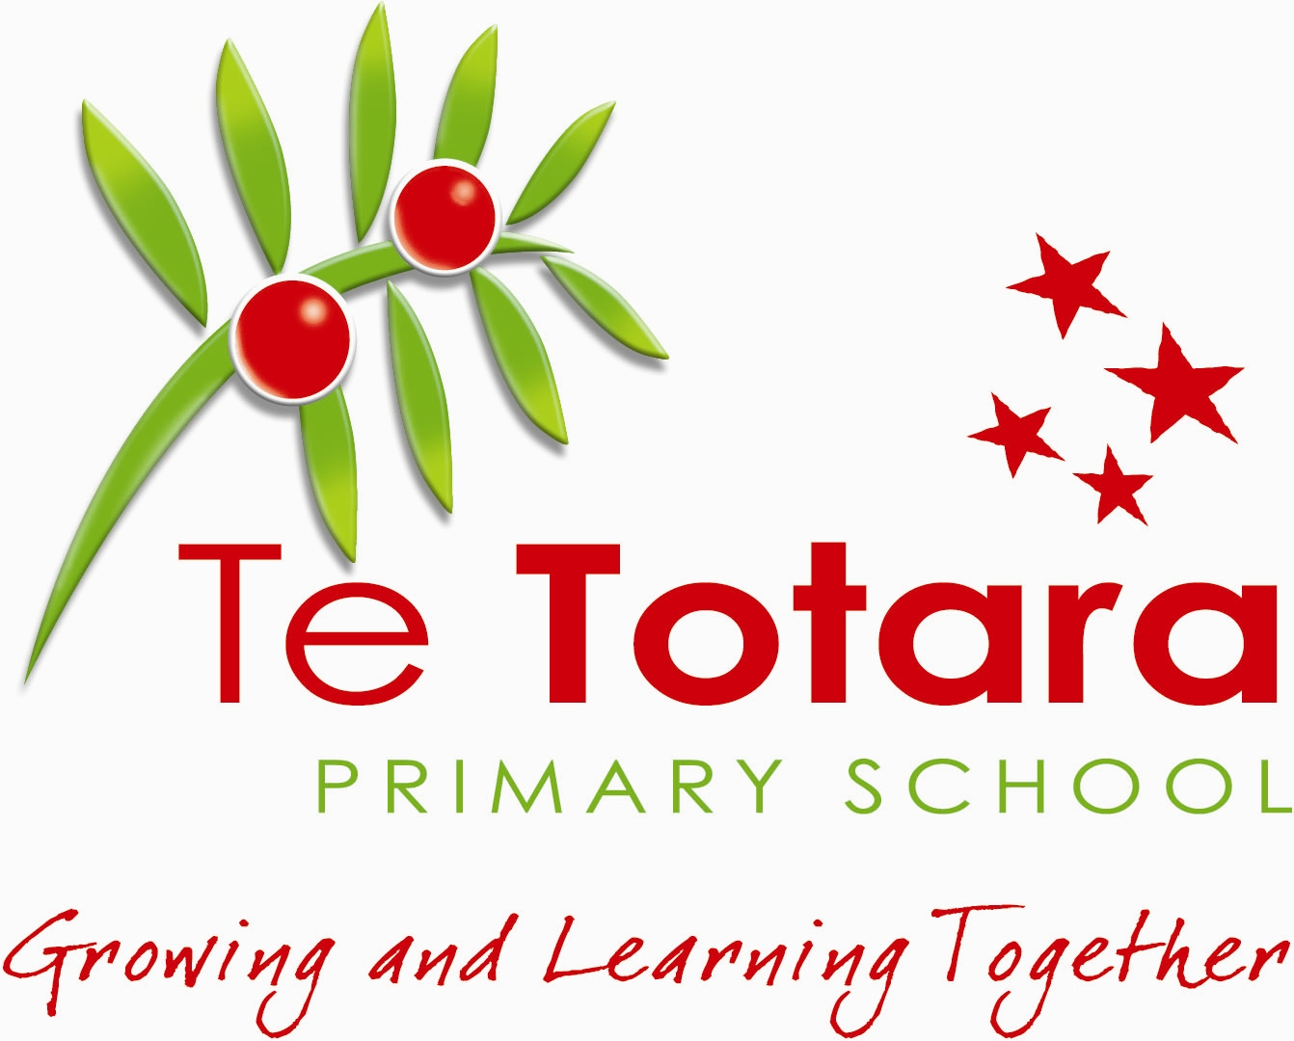
TE TOTARA
PRIMARY SCHOOL

POLICY: STRATEGIC PLANNING & SELF REVIEW

Why have this policy?
Te Totara Primary School recognises that to continually improve there must be a cycle of review, planning, implementation and review to support students learning
What is it for?
To support the growth and development of the school by taking into account the needs of the Learners, Staff, Community, School Board and Ministry of Education with a clear focus on:
- A focus on the learner
- Leadership in an inclusive culture
- Effective teaching
- Engagement with parents, whānau and communities
- Coherent policies and practice in a cycle of continuous self-review

The following review systems processes outlined in Appendix A will take place to support the above objectives.

Presiding Member …………………………..... Principal ……………………….....

Date Ratified: 21 September, 2023 Review Date: September, 2025

