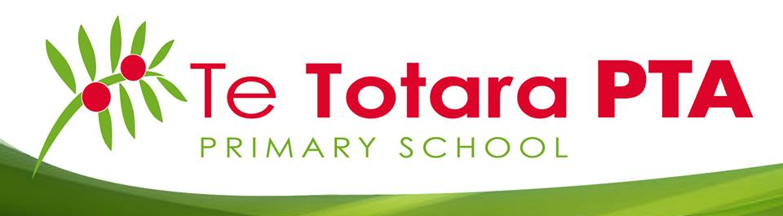
Te Totara Primary School Parent Teacher Association (PTA)
Position Agreements

Position Agreement – Chairperson

To succeed she/he needs to secure participation, co-operation, harmony and a sense of responsibility from the members to display initiative, working spirit and ability. The President should aim to have a complete knowledge of the organisation and its possibilities, its aims and methods, its history, members and spirit.

The Chairperson should:
  - encourage – participation, growth of committee members, respect and thoughtfulness, fun and laughter
  - monitor what is being done by the organisation
  - evaluate any events that are underway
  - delegate – some people in the organisation have better skills than you in certain areas – give them the jobs
  - be a facilitator – not a dominator
  - plan for change, development of members and the organization
  - keep a clear view of the PTA in mind – use brainstorming techniques etc
  - Liaise with all the necessary people – e.g. Principal, teachers, Board of Trustees, other parents who are not on the PTA Committee.

Duties of the Chairperson:
- Ensure meetings are planned and communicate with the secretary to ensure there is an agenda and the meeting has been communicated to members.
- Facilitate the meetings – making sure the meetings start on time and keep on track; introduce new faces, read and call for apologies; ensure minutes are approved from the previous meeting; and ensure conclusions are reached and tasks are assigned.

Position Agreement – Deputy Chairperson

He/she presides at meetings and does other presidential work in the absence of the Chairperson. He/she endeavours to take as much administrative weight off the Presidents shoulders, particularly in routine affairs. The Deputy Chairperson should be a good listener and supporter of the Chairperson.

Duties of the Deputy Chairperson:
- Chair meetings when the president is absent.
- Ensure finances appear reasonable. Check to ensure deposits reconcile to deposit forms signed by cash received from members. This can take place at the general meetings.
Position Agreement – Secretary

The two main jobs of the secretary are to keep the official records of meetings through the minutes and to deal with all inwards and outwards correspondence.

Duties of the Secretary:
- Minute taking and circulation into the school website & facebook page.
- Recording and responding to all inwards and outwards correspondence.
- Liaison with the Chairperson – agenda and general running of the organisation and meetings.
- Keep comprehensive records.
- Maintain mail box at Te Totara.

Position Agreement – Treasurer

The treasurer administers the funds of the organisation. They receive and disperse funds on behalf of the organisation and are responsible for accurate financial recording keeping. Transparency and attention to detail are essential.

Duties of the Treasurer:
- Open and maintain a bank account in the name of the PTA.
- Receive cash from members. Treasurer must ensure all cash received has been counted and verified by at least two of the Members organising the event before receiving it. The members are to sign a form detailing the amount to be deposited.
- Ensure there is a breakdown of funds deposited, so deposited funds per the bank account reconciles to the signed deposit forms from members.
- Ensure that true and fair accounts are kept of all monies received and expended.
- Prepare annual financial statements, including a record of profit and loss and a full balance sheet.
- Present a Treasurers report to each General Meeting which will include but is not limited to, an Income and Expenditure statement showing all income raised, and expenditure incurred, for each fundraising event and all movements in the Trusts bank account since the last meeting.
- Check all invoices to ensure expenditure appears reasonable and prepare cheques for signing.
- File an Annual return with the charities commission.

Position Agreement - Communications Officer

The Communications Officer will work closely with the Secretary to ensure to all communications in and out are administered correctly and efficiently.

Duties of the Communications Officer:
- Ensuring meetings are advertised in the school newsletter.
- Setup and maintain the PTA facebook account.
- Liaising with school about insert into the school newsletter each week.
- Ensuring the school website is kept up to date with necessary information.
- Setup and maintain email inbox.

Position Agreement – Event Co-ordinator

The two key objectives of the Event Co-ordinator is to:
- provide guidance and support to event subcommittee’s through an effective event framework, to ensure PTA events are well run and successful
- provide a clear communication “channel” between event subcommittee’s and the executive committee

Main duties of the Event Co-ordinator:
- Collaborative planning to map out events during the year to ensure PTA objectives are achieved
- Enrolling necessary support to create subcommittee’s to run PTA events
- When necessary attending sub committee meetings to provide support and decision making, and to report back to the executive committee on the progress of events
- Liaising with current PTA executive committee members and enrolling necessary support from respective members as/when required

These position agreements comes into force on ________________, and shall remain in force until altered in accordance with the provisions of the Te Totara Primary School PTA constitution.

Signed:

Chairperson

Deputy Chairperson

Secretary

Treasurer

Communications Officer

Event Co-ordinator

