2020-2023 Charter, Strategic and 2021 Annual Plan

Our Aim and Values
Growing and Learning Together

Our Purpose
For our school community to be:

- Smart Decision makers leading to individual excellence and positive reinforcement of one’s self, the school culture and whole community

- Trying our Best to achieve success, grow and develop new skills, meet targets and surpass expectations

- Always Learning and growing individual and team academic, professional and social skills

- Respectful at all times of cultures, beliefs and decisions within our school and wider community. Embrace cultural diversity and encourage the learning of Te Reo Maori and Tikanga

- Self-Managing and taking ownership for learning, motivating and celebrating success

About Te Totara Primary School

- Located at 31 Hector Drive, in the fast growing Rototuna suburb in North East of Hamilton, New Zealand

- Opened in January 2008 with 58 students, at December 2020 had 808 students

- Has 35 Learning areas, that includes two Satellite classes from Hamilton North Special School, an Administration area that includes resource area and offices, also a Multipurpose area containing a Hall and Staff Lounge

- Has an Individual Learning plan for each student and teacher to help them develop and fulfil our Mission of “Growing and Learning Together”.

- Has a diverse community, with over 25 different nationalities (using the Ministry of Education designations), making for a great school. This includes 37.3 % NZ European, 12.4 % Maori students, 1.5 % Pasifika, 14.8 % Chinese, 8.5 % Indian, 10.5 % African and 15.0 % other nationalities including ‘other European’.

- Has a supportive community who are active in the school through groups such as the Board of Trustees (who govern the school) Parent Teacher Association and Whanau.

- Is an active member of Te Pae Here, Kahui Ako, a large Community of Learning situated in the North-Eastern area of Hamilton City.

- Strong links have been established with Ngati Wairere, through the cultural report commissioned prior to the opening of Te Totara School. This report is evidenced within the ethos of the school and visibly linked through the names of the buildings and our Reach for the STAR’s programme. This is also reinforced through their stewardship of Te Pae Here, Kahui Ako.

- As the school has grown strong relationships have also been fostered with Kirikiriroa Marae through the schoolwide visits to this urban marae every second year. This was instigated as a result of consultation with our Maori community who continue to reinforce the importance of this link. Our students have a rich bond to Kirikiriroa and in their pepeha refer to it as ‘my marae.’

- Runs a Before and After School care programme catering for over 120 students daily.

- For further information visit www.tetotara.school.nz

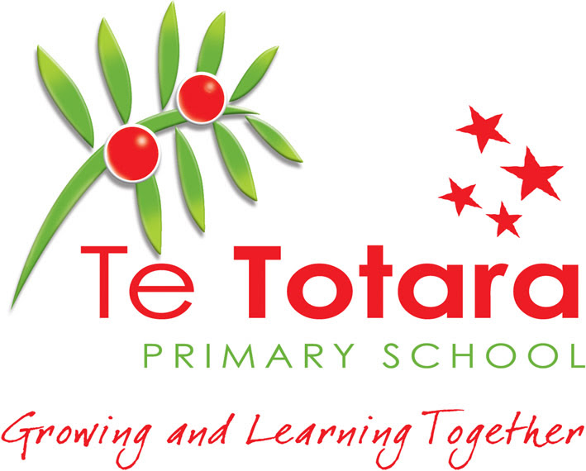

Strategic Plan 2020-2023
& Annual Plan 2021

Contents and Background

Pages 1-5 | Strategic Plan 2020-2023. This sets out the aims of the School over a four year period.
Pages 6-7 | Map of Action. This sets out when the plan will be implemented.
Pages 8-17 | Annual Plan 2021 Details the Actions, Responsibilities, Resourcing and Monitoring of the plan.
Pages 18-20 | Achievement Data 2020 Tables of year end data in Reading, Writing and Mathematics to inform 2021 Targets
Pages 21-26 | Specific targets to lift achievement in 2021. Details the targets we have set to lift achievement.

Principal’s Endorsement:
Board of Trustees Chair:
Submission date to Ministry of Education:

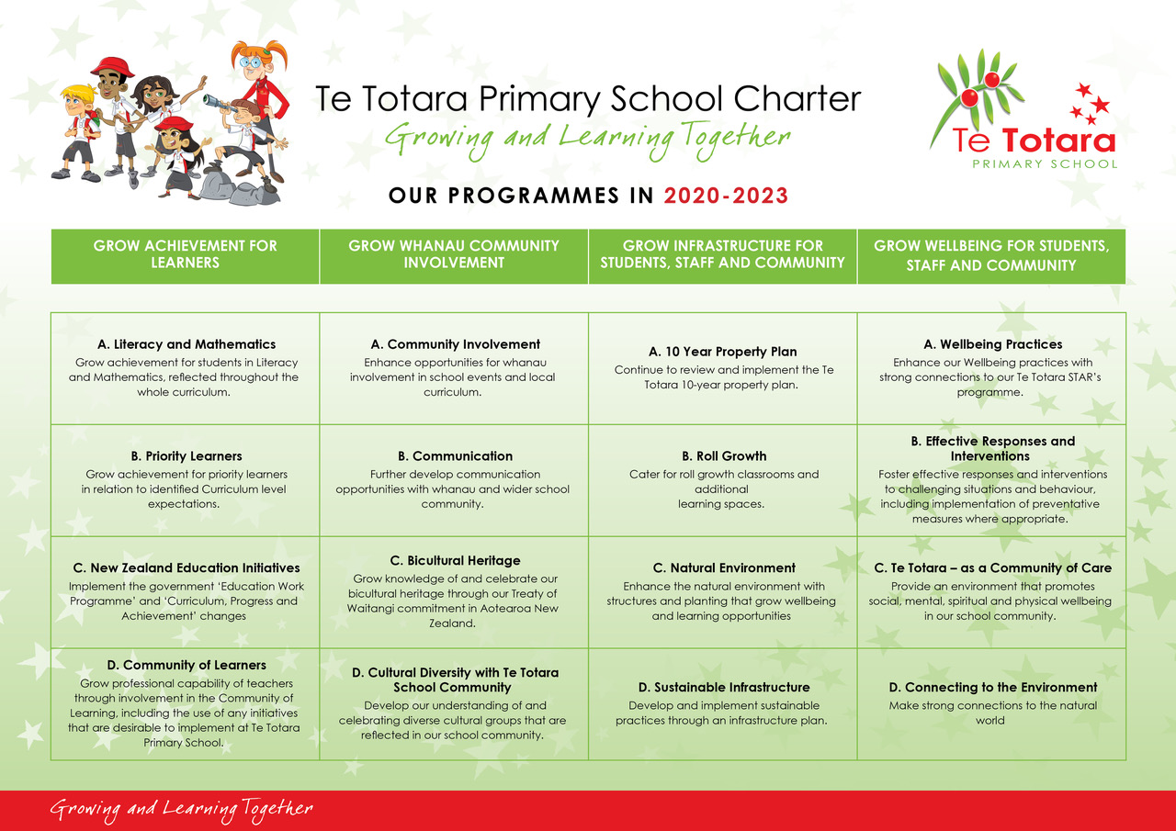
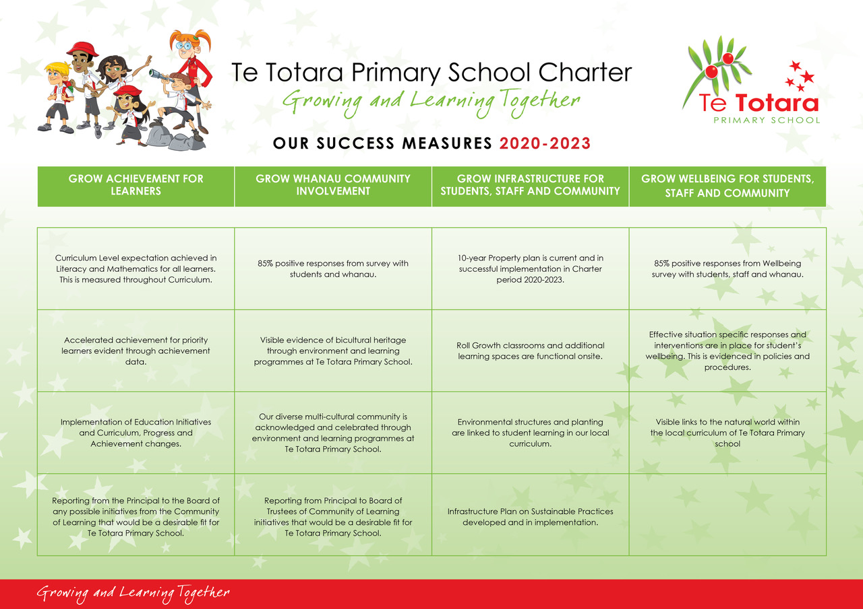
MAP OF ACTION
Grow Achievement  for Learners | 2021 | 2022 | 2023
Literacy and
Mathematics
Priority Learners
New Zealand Education Initiatives
Community of Learners (Te Pae Here Kãhui Ako)
Grow Whanau Community involvement
Community Involvement
Communication
Bicultural Heritage
Cultural Diversity within Te Totara Community
Grow Infrastructure
10 Year Property Plan
Roll Growth
Natural Environment
Sustainable Infrastructure
Grow Wellbeing for Students, Staff and Community
Wellbeing Practises
Effective Responses and Interventions
A Community of Care
Connecting to the Environment

1.Grow Achievement for Learners; Priority and other Learners

Action | Who RACI | How | Resourcing | When | Evidence of Success
A. Literacy and Mathematics  Curriculum Expectations in Literacy are achieved through high quality teaching and learning. | Responsible: DP,  Accountable: P, DP, AP, Leaders, Teachers, Learning Support  Consult: Staff  Inform: P, BOT | -Develop opportunities for strategic thinking and actions of the leadership team to support schoolwide literacy programmes e.g. expos, school guidelines, quality assurance practices.  -Professional development in early literacy practices. Focus areas: Phonemic awareness, Casey Caterpillar, Better Letters, Building Blocks/Connections to Play Based Learning.  -Continue to informally liaise with Elsbeth Oliver (R.T. Literacy).  -Continue focus on high quality feedback/feed forward and moderation processes. | -Share Literacy Data and report with: Staff, BOT and C.O.L.  -Apply for ‘Better Start Literacy Approach’ Programme, (funded by the MoE, delivered by University of Canterbury)  -Targeted Teacher Aide support in Reading and Writing particularly in Yr 1-2. | Teacher Only Day  analysis of 2020 data.  -by Feb 8, 2021  -Jan-Feb Staff and Team meetings  (Term 1-4)  -March 2021  -Ongoing Term 3 Exemplar and school-wide moderation.  -Year End Review of 2021 data. | -Student achievement is maintained that almost all students (91%) achieve cohort Curriculum level expectation.
A. Literacy and Mathematics  Curriculum Expectations in Mathematics are achieved through high quality teaching and learning. | Responsible: DP,  Accountable: P, DP, AP, Leaders, Teachers, Learning Support  Consult: Staff  Inform: P, BOT | -Develop opportunities for strategic thinking and actions of the leadership team to support schoolwide mathematics programmes e.g. expos, quality assurance practices, professional goals, ‘seed learning’ discussions at team meetings.  -Professional development with staff new to Te Totara. Targeted staff meetings particularly to Yr 3-4 level.  -Review effectiveness of practice in Year 1-2 through observations, specific feedback and resource support. | -C.O.L. in-school team leading teacher inquiries in Maths  -Yr 1-2 staff P.D.  -Bruce Moody (external facilitator P.D.) Budget $15,000  -Targeted Teacher Aide support in Maths particularly in Yr 3-6.  -0.4 FTTE Teaching and Learning Time. | Teacher Only Day analysis of 2020 data.  External Facilitator present at school each term up to 12 days total.  Year End Review of 2021 data. | -Student achievement is maintained that almost all students (91%) achieve cohort Curriculum level expectation.
B. Priority Learners  Priority Learners- continue to target lifting achievement, focus on Equity and Excellence | Responsible: DP,  Accountable: P, DP, AP, Leaders, Teachers, Learning Support  Consult: Staff  Inform: P, BOT | -Develop opportunities for strategic thinking and actions of the leadership team, in goal setting and learning support for priority learners.  -Focus on differentiated class programmes.  -Initiate contact with whanau within the first school month of identified Priority Students.  -Regular update of Priority Learners document with quality teaching that works with the Learner.  -Review mid and year end data and link to forward planning for 2022. | -Michele 0.4 FTTE with Priority learner’s role  -Learning Support Coordinator position 1 FTTE and .4 FTTE (Michele)  - Teacher aide targeted support  -0.4 FTTE Teaching and Learning Time  -C.O.L. In School and Across School Leaders. | Ongoing  Ongoing  June/Dec 2021 | -Priority Learners and groups - Maori, Pasifika, European, Asian, Male, Female are within 3% of expected achievement levels and above. This is 91% in curriculum levels in Reading, Writing and Maths.
B. Priority Learners  Learning Support Coordinator Positions | Responsible: P, AP, priority Learners Leader  Accountable: P, AP, Learning  AP, Learning Support Coordinators  Consult: P, AP, DP,  Inform: P, COL, M.O.E, B.O.T. | - Implementation process continues for our Learning Support Coordinator.  -Appraisal of our Full time LSC completed and new goals and actions set.  Link transferred staffing from Te Ao Marama to priority learner’s leader and create LSC aspects of her role.  -Base new roles within existing successful contexts at Te Totara.  -Develop clearly identified roles for each LSC/Priority Learners leader/E.S.O.L. team so that unnecessary duplication is not occurring within roles and each person is positively contributing in an effective manner.  LEARNING SUPPORT PLAN 2021.docx | -M.O.E. resourcing:  -1.00 FTTE Learning Support coordinator based at Te Totara  -0.46 of a shared Learning Support coordinator based at Te Ao Marama  Transition time for A.P. & Priority Learners leader. | February 2021  Ongoing 2021 | -Learning Support Coordinators effectively transitioned onto the staff and the Te Totara culture  -Trust of staff is developed  -Effective working practices are in place with Senior Leaders, Team leaders, teachers and support staff.  -Learning Support delivery is maintained as a ‘best practice’ model  -Successful liaison with M.O.E.
B. Priority Learners  Consolidate teacher capability & responsiveness to needs of students who are English Language Learners (Priority students), lifting achievement and whanau involvement. | Responsible: AP  Accountable: P, AP, Learning Support Coordinators, E.S.O.L. teachers  Consult: P, DP, AP, Staff  Inform: P, BOT | -Introduce new Language Learning Pathways Years 1-8 documentation to the teachers on Teacher Only Days prior to school starting.  -Utilise the strengths of E.S.O.L. teachers, Priority Learners leader and Team Leaders to support teachers, through modelling, sharing of and working alongside teachers in their context.  -Include in professional goals for Teachers.  -PLD sessions with staff to support them in their role, focus on academic and social language.  -Utilise In-School COL positions to support ELL, these are four appointed teachers who are resource persons to support colleagues. | M.O.E. resourcing for Teacher and Teacher Aide  Time as detailed below:  -1.0 FTTE for ELLP, with a component on using the resourcing for Teacher support (2 staff; 1 is 0.4 and 1 is 0.6.  $40,000 Teacher Aide time to support E.S.O.L. literacy programmes e.g. Talk to Learn, Alien Talk, Oral Language Support, STAR’s Learning.  -PLD for E.S.O.L. staff to support teacher’s assessment and teaching programmes for E.S.O.L. | Jan 2021  Ongoing throughout 2021  Ongoing throughout 2021 | -E.L.L.P. decisions are made by teachers in a confident and consistent manner  -Professional Goals achieved for Teachers,  -Student Targets for Learning are met and students evidencing strong progress towards second language acquisition during years at Te Totara.  -Funding is secured through twice yearly reporting to Ministry of Education.
C. New Zealand Education Initiatives  Digital Technology  curriculum plans link in year level programmes. | Responsible: P, DP  Accountable: DP, Teachers  Consult: Staff  Inform: BOT | -Teachers self-review in this area have led to 2020/2021 goals in own learning area.  -Utilise the expertise of staff members as part of ongoing PLD programme for teacher.  -Team Leaders developing teaching programmes at year levels including Planning and Assessment sheets (P &A’s).  - Full implementation evidenced with growing capability and confidence in team year level programme in place for 2021.  -Kahui Ako Digital Technology resources are being utilised through learning area programmes. | -Ongoing budget for Curriculum resources  -Teaching and Learning time.  -All teachers complete the Digital Passport Workshops 1 and 2. | Teacher Only Days January  Continued PLD during 2021 | -Programmes evident in planning and classroom delivery, Performance Management system self-review.  -Digital Technology curriculum in full implementation in 2021. Coherent Learning Pathways are evident.
C. N.Z. Education Initiatives  Utilise Education system to support student achievement | Responsible: BOT, P, DP, AP, Staff  Accountable: P, BOT  Consult: Students, Teachers, Whanau,  Inform: P, BOT, MOE | -A raft of changes in education are planned, keep abreast of these, plan and implement to ensure there is a continued focus on equity and excellence.  -Familiarise Board and staff with the National Education and Learning Priorities (NELP).  -Plan how its priorities are best achieved within our context and assess how we might shift our focus so that the priorities become part of our everyday practice.  -Review current policies (as per review cycle) and practices in place, identify links the N.E.L.P’s priorities. | -Review and discuss with Leadership team the M.O.E. Strategic Plan for Education.  -Time, allocate these discussions and responses within school and BOT meetings.  -Tools and resources to be shared by the Ministry of Education.  Senior Leadership and Leadership time. | Ongoing  N.E.L.P. came into effect 13 Nov 2020  Term 1.  Term 1, 2021 through to full implementation in 2023. | -School runs smoothly, with a continued focus on what is best for students, staff and community.  -Targets in relation to student achievement are met.  -Understanding of N.E.L.P. priorities are developed during 2021.  -Implementation process begins through policy and procedural review cycle.  -Alignment of practice begins.
D. Community of Learners  -Monitor Oral Language/  Writing achievement level gains over past 2 years.  -Consolidate Teacher capability & achievement through key Inquiries in Maths | Responsible: DP  Accountable: P, DP. AP  Consult: P, AP, COL  Inform: BOT | -Continue to monitor student achievement in Oral Language, implementing necessary responses to develop this further, including how we are lifting student achievement in this area.  -Consolidate Key indicators to show value added with Feb and Nov 2021 data to reflect progress.  -Use data to plan deliberate acts of teaching through curriculum.  -C.O.L. in-school teachers support teachers to grow their Maths by learning through their own inquiries.  -Support the targeted professional development sessions of facilitator Bruce Moody. | -COL Resourcing through targeted time.  -Senior Leadership support with growing C.O.L. in-school staff capabilities.  -$15,000 for professional development facilitator. | Ongoing  12 days over 2021 | -Oral Language indicators in use, with pre and post analysis.  -Increased student proficiency evident through staff feedback in Oral Language and Writing.  -Positive achievement evident in end-of-year data.  -Diagnosis of learning needs through inquiry and high-quality teaching to enhance Maths learning.
D. Community of Learners  Continue to strengthen student ownership and wellbeing through Learning/ Student Agency and our learning area wellbeing. | Responsible  DP, P, AP  Accountable  Leadership, C.O.L. In-school and Across School Teachers, Teachers and Students  Consult  Students, Teachers, Whanau,  Inform  Principal, BOT | -Collate and analyse state of current practices, include surveying students, teachers, and whanau.  -Examine research and other contexts of learning.  -Come to a shared understanding of practices to support student ownership and agency within their learning settings.  -Implement a P.L.D. programme to support teachers and students to strengthen ownership of learning to learn.  -Include in-school C.O.L. teachers and Leaders professional goals and Inquiries to support them in their practice.  -Involve C.O.L. Across School personnel using practices that are based on ‘Rongohui te Hau’ model to develop culturally responsive practices that link to enhanced student agency. | -Teaching and Learning Time 0.4 FTTE to support professional goals  - PLD through COL across school positions  -Staff Meeting  Team meetings  -Targeted resource buying  -C.O.L. Across School personnel. | Ongoing  Term 2-3 2021  Term 2-3  2021 | -Survey students  -Survey Teacher  -Planning and Assessment sheets  -Quality Assurance  -Teacher Inquiries and reflections.  -Student agency evident through curriculum planning and classroom practice.

2.Grow Whanau and community involvement

Action | Who RACI | How | Resourcing | When | Evidence of Success
A. Community Involvement  Consult & implement new MOE guidelines for Charters, Annual and Strategic plans for 2020-2023  Undertake consultation with community on the health component of the curriculum | Responsible: BOT, Principal  Accountable: BOT, Senior Leadership  Consult: BOT, Staff and Community  Inform: BOT, Community | -Consult and update the Charter, Strategic and Annual plan each year to reflect community and Ministry of Education Guidelines.  -Ensure that the community views are considered and reflected in school programmes and decisions.  -Strategic and Annual Plans are to increasingly reflect National Education Learning Priorities (N.E.L.P.)  -Undertake consultation on our health and wellbeing curriculum as required every two years and reflect community wishes in the health programme. | -Time to consider new guidelines from MOE for 2021 and beyond  Time to consult with community.  -Survey creation and analysis | New planning format adopted by 1 March 2020 and ongoing review to ensure guidelines are updated.  -Health consultation by end of Term 3 2021. | -New Charter format (completed 1 March 2020) reflected full community consultation.  -Yearly implementation of the strategic intent of the Charter. reflecting community decisions.  -Clear communication to the community is evident.  -Curriculum programming is shared. Consultation undertaken and actions taken are communicated to the School community.
A. Community Involvement  Enhance opportunities for whanau involvement in school events and local curriculum | Responsible  P, DP, AP,  Teachers  Accountable: All  Consult  Staff, Whanau and students  Inform  B.O.T. Whanau | -Meet the Teacher evening.  -P.T.A. Events – Parent evening – Sustainability speaker, Sponsorship of new Wellbeing garden and seating, Student Discos, Spellathon, Ice block days.  -Learning Plan discussions (student, teacher and whanau), co-constructed goals.  -Weekly assemblies to share learning. Parents invited.  -Sports teams coaches and managers  -Sports days  -Learning Expos  -Term 2 Social Sciences unit - Manaakitanga  -Junior Production  - Schoolwide Arts Exhibition – Term 3 (Families visit)  -Year 6 leavers  -Volunteers thank you cards & event  -End of Year Celebration Dec 2021. | -Time from Senior leadership and teaching team  -Publicity for events via Seesaw, website, Facebook and newsletter.  -Sports team leaders to facilitate  -Transport costs $500  -Transport costs $500  -Budget $3000  Unit for production facilitator $4000  -Budget: $500  -Budget: $500  -Budget $100  -Budget: $1100 | Feb 2021  March 2021  Feb-Mar 2021  March 2021  Ongoing  Ongoing  Term 2 2021  Term 2 2021  June 2021  Dec 2021  Dec 2021  Dec 2021  Dec 2021 | -Many opportunities for Whanau to be involved and connected to Te Totara school life.  -P.T.A. supported by school staff and community  Families active participants in student learning plans.  -Vibrant school life with many opportunities for involvement in Sports, the Arts and local Curriculum.  -Successful year end events reflecting high levels of community involvement.
B. Communication  Keep community informed through Social media including Facebook, Website TTTV, Seesaw | Responsible  Digital Leader, admin team, Teachers  Accountable  P  Consult  BOT  Inform  BOT | -Enhance electronic school signage.  -Investigate an electronic noticeboard.  -Ensure community and parents/caregivers have current and relevant information relayed to them with translation into own language.  -Use TTTV to help parents with School events and ways of working i.e. drop off zone use, Moonlight drive pedestrian rules.  -Use Seesaw and TTTV to share our learning and goals to community.  -Be prepared for any extension of Home Learning as a Covid 19 Alert Level response. Use Seesaw portal as this was successful in 2020 pandemic. | -School Investment Package funding  -Time and resourcing for Digital Leader,  -Digital Student Leaders developing TTTV episodes every 2 weeks.  -Teachers responsible for enhanced learning, funding as needed. | Ongoing  Term 1/2 2021  Ongoing  Ongoing through school year  As required. | -Community are well informed, include feedback from community survey if needed.  -Positive feedback from community regarding the communication channels we have.  -Families interacting with students and teachers via Seesaw both inside and outside of school as determined by pandemic responses.
C. Bicultural Heritage  Tikanga and Te Reo expectations and support, continue the programme of Te Reo support through Curriculum for teachers.  -Grow teacher knowledge of Aotearoa/New Zealand History through Kahui Ako links with Tanui and Ngati Wairere. | Responsible: P, DP, AP, Teachers  Accountable  Senior Leadership, Whanau committee, Haka Hiva for Kapa Haka,  teachers  Consult  Staff, Whanau  Inform  B.O.T. Whanau | -Continue to support Tikanga in all learning areas.  -Reinforce previous professional development.  -Increase proficiency of staff in te reo Maori.  -Support individual teachers through their own te reo development through Te Wananga o Aotearoa.  -Link this to Performance Management processes. Staff self-review their own development in Appraisal conversations and set goals.  -Through Kapa Haka performances host whanau events to enhance regular consultation with Maori community.  -Register interest of Te Totara in being involved with Draft NZ Histories Curriculum trialing and feedback to M.O.E. curriculum unit.  -Kahui Ako Teacher only Day for all teachers in Te Pae Here Professional Learning Day: ‘Whakatakoto i te whakaaturanga mo ngā Hitori ō Aotearoa’ (Setting the scene for Aotearoa New Zealand Histories.) | -0.2 FTTE to support teacher’s growth in Tikanga  $4000 unit for staff member responsible for Whanau  -Tikanga funding including Haka Hiva Kapa Haka programme $8700  -Hospitality funding for these events $500 | Tikanga support from early Term 1  Kapa Haka and Staffroom Te Reo -all year  Twice a year  May & Oct 2021  Term 1-2 2021  4 June 2021 | -Ongoing Tikanga programme.  -Acknowledgement of staff professional growth in this area through performance management process.  -Staff have new 2021 goals in Tikanga and Te Reo.  - Student knowledge and participation in bicultural practices is increasing.  -Whanau attendance at Kapa Haka and other school events is high and consultation is positive.  -Maori community have a forum to share ideas.  -Te Totara contributes to development of new NZ History document. We begin our learning journey with this in 2021 well ready for full implementation in 2022.
D. Cultural Diversity  Develop our understanding of and celebrating diverse cultural groups that are reflected in our school community. | Responsible  BOT, P  Accountable  P, D.P. A.P. Staff, Diversity leader  Consult  BOT, Community Liaison, Families  Inform  BOT, Community | -Community Liaison officer reaches out to families  -Community committee has staff member with a unit around Diversity.  -Talents of the Pasifika Academy (T.O.P.A.) developing Te Totara Pasifika cultural group, performances shared across school and wider community three times a year.  -Significant cultural events are linked to local curriculum.  -Term 1 focus ‘Chinese Lantern festival.’  Term 2 focus ‘Kotahitanga/Manaakitanga’  -Continue to add to the flags of our cultural groups displayed in the Matariki Hall. | Marise Crow  $4000 unit for staff member  Budget: $1500  $800 for named flags | Ongoing  Ongoing  As new cultural groups enrol. | -Our community feel comfortable and connected to Te Totara School  -Diversity of community is acknowledged and valued  -Strong Pasifika group in place with high participation from the students  -A rich understanding of celebration is developed within our students  -Flags acknowledging the cultural groups belonging to Te Totara are a visible sign of our diverse heritage

3.Grow infrastructure for Students, Staff and Community

Action | Who RACI | How | Resourcing | When | Evidence of Success
A. 10 Year Property Plan  Complete all the actions of the 10 Year Property plan. | Responsible: BOT, P  Accountable:  BOT, Staff  Consult:  BOT, Staff  Inform: BOT | -Review the 10 year plan in the light of the School Investment package to see if works can be bought forward.  -Upgrade of interiors of Earth and Ra block (carpets and lino).  -School Investment projects are underway, and all completed by end of 2021 (hall floor covering replacement April holidays, turf replacement, shade sail replacements, Solar panels installed and fully operational to reduce school energy footprint.)  -Student learning linked to Solar energy information so they can understand the ‘sustainability model.’  -Develop further works programme from a review of school upgrade needs. | -Agreed 10 Year plan  -School Investment Package funding $400,000. | Term1 2021  2020-2021  Dec 2021 | -Review work is completed.  -Programmes have been completed.  -An upgrade works schedule has been developed and an effective plan is underway.  -Earth and Ra block refurbishment underway in main year end break. and are completed by start of 2022.  -School Investment projects are underway, and all completed by end of 2021.
B. Roll Growth  Liaise with MOE over roll growth and subsequent implications on future building work. | Responsible: P, BOT  Accountable: BOT  Consult: BOT, MOE  Inform: BOT, MOE | -Additional two roll growth classrooms announced by Minister of Education:  -New Learning area is connected to the Matawhero block to make that a block of 5.  -Current Kopu block of two classrooms is shifted back towards the northern boundary and new roll growth classroom is added to the western end of this block. Veranda is redeveloped to link these areas.  -MOE and Te Totara is to explore the growth potential created by the closure and removal of the Barnado’s early childhood centre on MOE leasehold land. | -Ministry of Education roll growth funding.  -Liaison time with MOE and possible consultation with staff and community  Ongoing dialogue with M.O.E. | Determined by M.O.E.  Block shifting  Term1 2021  Building occurring  Term 1 2021  Feb/March 2021 | -Additional learning areas created at Te Totara to allow for well-managed roll growth.  -New Learning areas are completed in a timely manner and linked cohesively to existing structures, reflecting our pedagogy.  -Any future developments are well planned and allow the school to focus on student learning in appropriate infrastructure.
C. Natural Environment  Enhance the natural environment with structures and planting that grow wellbeing and learning opportunities | Responsible: P, BOT  Accountable: Leadership, Staff Caretakers, School Council,  Consult: PTA, BOT, Students, staff  Inform: BOT, Community | -Develop additional garden areas at Te Totara, particularly with the completion of the wellbeing/memorial garden.  -Increase the student seating areas in the natural environment.  -Enhance planting and structures to encourage student investigation and participation  -Identify clear links to the natural environment in the Yearly curriculum overview. | -School Council Planning from 2019-2020 $5000  -In conjunction with P.T.A.  $20,000 | Autumn 2021  Autumn and Spring 2021  Ongoing | -Student’s visible enjoyment of physical activity and environmental experiences.  -Learning is holistic using environmental and cultural motivation.  -Students increasingly interacting with the Natural World through access to natural infrastructure being developed.
D. Sustainable Infrastructure  Develop and Implement sustainable practices through an infrastructure plan. | Responsible: P, BOT  Accountable: P, BOT, Staff, Students  Consult: BOT, MOE  Inform: BOT, MOE | -Explore current models of sustainable practice within schools from small changes to larger projects.  -Continue to focus on reduced energy usage and solar energy. School Investment Project funding for this. Solar installation complete.  -Survey completed of lighting. Upgrade of all lighting to energy saving LED’s as they need to be replaced.  -Develop a plan for more sustainable practices at Te Totara.  -Continue to make staff and students aware of sustainable practices via curriculum and day to day school functioning. | -Time for senior staff to explore this.  -Determine on Solar energy provider and installer. S.I.P. Funding $152,000 (GST incl) allowed.  $1500 each year  -Partnership between BOT & Leadership to develop this. | Term 1-2 2020  Term1 2020  Ongoing as required  Term 4 2020  Ongoing | -Completion of a Sustainable Infrastructure plan  - Solar energy integrated into curriculum and day to day practises at Te Totara.  -Sustainable practices underway at Te Totara  -Student knowledge of and involvement in sustainability increasing.

4. Grow Wellbeing for Students, Staff and Community

Action | Who RACI | How | Resourcing | When | Evidence of Success
A. Wellbeing Practices  -Support wellbeing and positive school culture through mindfulness programmes for students and staff. | Responsible: Senior leadership and Wellbeing committee  Accountable: P  Consult: Staff, Students, community  Inform: B.O.T. | Continue implementation of a Te Totara Wellbeing programme incorporating aspects of Mindfulness, Tikanga, linked with our STAR’s programme.  Availability of trained mindfulness facilitator to support and advice delivery of the programme to classes.  -Continuing these programmes across the school: Zones of Regulation, Proprioceptive Techniques and linking/reinforcing all programmes to our STAR’s.  -Contract for Employment Assistance to support staff wellbeing… www.eapservices.co.nz | -Funding of Mindfulness resource teacher 1 FTTE for Terms 1,2 &3.  -Additional resource purchasing  -Time for Assistant Principal to work with class teachers  -Funding of Employee Assistance programme; $3500 per year. | ‘Mindfully Me’ curriculum programme Terms 1 2021.  -Ongoing Mindfulness, STAR’s, Zones of Regulation regularly and as needed.  -Incorporate aspects of ‘Te Whare Tapa Wha’ into Mindfully Me focus area.  -Employee Assistance programme ongoing and staff regularly updated on access. | -Student, parent and staff feedback on Mindfulness programmes.  -Classroom teachers feel confident to deliver the mindfulness programme to their learning area.  - A unique Te Totara Wellbeing programme is developed and being regularly implemented in all learning areas.
B. Effective Responses and Interventions  Foster effective responses and interventions to challenging situations and behaviour, including implementation of preventable measures, where appropriate. | Responsible  P, DP, AP, BOT (as appropriate)  Accountable  P, DP, AP, BOT  Consult: Staff, Families, COL  Inform: BOT, MOE, Families, Staff | -Continue to develop wellbeing programmes as detailed above.  -Regular review of Policies and Procedures: Stand down, Suspensions and Exclusions policy  Student Behavior Policy.  -Implement with staff the Prevention of Bullying policy and Procedures.  -Continue to work closely with supporting agencies and families to create sustained and effective interventions for their children.  -Continue professional development of staff in the Incredible Years for Teachers Programme.  -Health and Wellbeing programmes reviewed and linked to the C.O.L. Taakaro-Ora programme. Liaise with their staff for advice.  -Principal to attend New Zealand Principal’s Conference. | -Research into current approaches and responses  -Additional resource purchases  - Time for Senior Leadership/Staff meeting.  -Targeted Teacher and Teacher Aide time to support students.  Guest Teacher Release for three teachers on the ‘Incredible Years’ programmes.  -$1000 Conference  & Accommodation. | Ongoing 2021  Ongoing 2021  Feb 2021  Ongoing 2021  Teacher Only Day 2021  Terms 1-3 2021  August 2021 | -Responses are effective with positive interventions in place.  -Students feel supported and that we can ‘make a difference’ with them.  -Learning within social situations is occurring relevant to the child’s developmental needs.  -Families/Whanau are in partnership with the school and appropriate external agencies if needed.  -School Leadership and staff have ongoing professional development opportunities in this area.  Principal involved in Professional Network and Development.
C. Te Totara – as a community of Care  Provide an environment that promotes social, mental, spiritual and physical wellbeing in or school community. | Responsible: Senior leadership and Wellbeing committee  Accountable: P  Consult: Staff, Students, community  Inform: B.O.T. | -Support families in need in both pastoral, practical ways and emotional support links where appropriate.  -Always commit to enhancing the dignity of the individual with students, staff and families.  -Sensitive engagement with support agencies.  -No barriers to participation in Curriculum programmes and the greater ‘life of our school.’  -Reinforce importance of Te Totara Community Liaison role.  -Staff Counselling available as needed.  -Social events for school and staff.  -Student pastoral and transition leaders.  -School Council representatives across school.  -School Tours for visitors.  -Active engagement with neighbouring preschools.  -Active engagement with retirement village. | -Curriculum trips are subsidised or fully paid for by school operations grant to reflect inclusive practices  -High quality secondhand uniforms given to families  -Te Totara stationery & aquatics funded for some families  -Marise Crow, additional hours as required  -Funding of E.A.P. for staff $3500 per year  -$4000 unit for Student Leaders staff member  -$4000 unit for School Council staff member  -Weekly visits by student transition leaders. Performance by choir and productions  Morning tea invitation for village neighbours. | Ongoing 2021  Ongoing 2021  Ongoing 2021  Term 1& 4 2021  Term 1,2&4 2021  Ongoing  Feb-Dec 2021  Each fortnight  Feb-Dec 2021  Feb-Dec 2021  4 school tours across each term  Weekly  Term 2 2021  Term 1 and 4 2021 | -Te Totara community feels supported in times of need.  -Equity of student access to opportunities within our school curriculum  -Partnership between families, school and agencies (where appropriate) are based on trust, positive and affirming.  -Staff and community feel supported with a high degree of relational trust and a sense of fun.  -Te Totara is seen as a ‘large family’ with caring staff and atmosphere who are here to help.  -Students leadership skills are being developed.  -Students are being prepared for their next learning environments.  -Strong bonds are maintained with preschool centres and retirement village close by.  -Te Totara Primary School is active and well-thought of within our local community.
D. Connecting to the Environment  Make strong connections to the natural world. | Responsible  DP  Accountable  P, DP, AP  Consult  P  Inform  BOT | -Incorporate new Wellbeing garden into our curriculum programmes.  This includes a memorial seat in honour of a student who passed away in early 2019,  -Share responsibility for our school vegetable garden with rostered teaching teams.  -Leisure areas linked to natural environment.  -Seek opportunities to investigate the natural world through local curriculum e.g. stories from Ngati Wairere, science links with the Kukutaaruhe Fairfield Project gully restoration, artworks, Camp.  -Make connections with learning through the environment. | -$25,000 for garden development,  $500 for memorial seat  -$1000 for ongoing planting and maintenance  -C.O.L. Te Pae Here | Autumn and Spring 2021  Each term  Term 2-4 2021  Ongoing 2021 | -Wellbeing garden is completed.  -School vegetable garden is planted with seasonal produce.  -Students learning about the cycles of nature and how to look after living things.  -Seating areas enhanced around the school to develop student’s social interactions.  -Teachers increasingly interacting with the Natural World through co-constructed curriculum opportunities with students.  -Students ‘notice’ and make connections to the natural world. They develop the NZ Curriculum values of inquiry and curiosity.

2020 Curriculum Level Expectations Reporting

Te Totara Primary School – All Students.
Data from Year End Reporting 16/12/2020

Reading | Not At |  |  | Working Towards |  | At |  | Exceeded |  | Total
 | Number |  | Proportion | Number | Proportion | Number | Proportion | Number | Proportion | Number
All students | 23 |  | 3.0% | 57 | 7.5% | 605 | 79.2% | 79 | 10.3% | 764
Māori | 3 |  | 2.9% | 9 | 8.7% | 84 | 81.6% | 7 | 6.8% | 103
Pasifika |  |  |  | 1 | 5.0% | 17 | 85.0% | 2 | 10.0% | 20
Asian | 7 |  | 2.7% | 24 | 9.3% | 202 | 78.3% | 25 | 9.7% | 258
N.Z. European/Pākehā | 4 |  | 1.5% | 16 | 6.0% | 207 | 77.8% | 39 | 14.7% | 266
All other Ethnicities incl Other European | 9 |  | 7.7% | 7 | 6.0% | 95 | 81.2% | 6 | 5.1% | 117
Male | 18 |  | 4.9% | 30 | 8.1% | 291 | 78.6% | 31 | 8.4% | 370
Female | 5 |  | 1.3% | 27 | 6.8% | 314 | 79.7% | 48 | 12.2% | 394
Reading | Not At |  |  | Working Towards |  | At |  | Exceeded |  | Total
 | Number |  | Proportion | Number | Proportion | Number | Proportion | Number | Proportion | Number
End of Year 0 |  |  |  | 1 | 3.2% | 30 | 96.8% |  |  | 31
End of Year 1 | 4 |  | 3.5% | 23 | 20.0% | 85 | 73.9% | 3 | 2.6% | 115
End of Year 2 | 6 |  | 5.1% | 9 | 7.5% | 101 | 84.9% | 3 | 2.5% | 119
End of Year 3 | 6 |  | 5.3% | 9 | 8.0% | 85 | 75.2% | 13 | 11.5% | 113
End of Year 4 | 4 |  | 3.4% | 6 | 5.0% | 90 | 76.3% | 18 | 15.3% | 118
End of Year 5 |  |  |  | 4 | 2.7% | 124 | 85.0% | 18 | 12.3% | 146
End of Year 6 | 3 |  | 2.4% | 5 | 4.1% | 90 | 73.8% | 24 | 19.7% | 122
2020 Curriculum Level Expectations Reporting

Te Totara Primary School – All Students. Data from Year End Reporting 16/12/2020

Writing | Not At |  |  | Working Towards |  | At |  | Exceeded |  | Total
 | Number |  | Proportion | Number | Proportion | Number | Proportion | Number | Proportion | Number
All students | 14 |  | 1.8% | 72 | 9.4% | 661 | 86.5% | 17 | 2.3% | 764
Māori | 1 |  | 1.0% | 12 | 11.6% | 89 | 86.4% | 1 | 1.0% | 103
Pasifika |  |  |  | 1 | 5.0% | 19 | 95.0% |  |  | 20
Asian | 3 |  | 1.2% | 23 | 8.9% | 226 | 87.6% | 6 | 2.3% | 258
N.Z. European/Pākehā | 5 |  | 1.9% | 25 | 9.4% | 228 | 85.7% | 8 | 3.0% | 266
All other Ethnicities incl Other European | 5 |  | 4.3% | 11 | 9.4% | 99 | 84.6% | 2 | 1.7% | 117
Male | 12 |  | 3.2% | 48 | 13.0% | 302 | 81.6% | 8 | 2.2% | 370
Female | 2 |  | 0.5% | 24 | 6.1% | 359 | 91.1% | 9 | 2.3% | 394
Writing | Not At |  |  | Working Towards |  | At |  | Exceeded |  | Total
 | Number |  | Proportion | Number | Proportion | Number | Proportion | Number | Proportion | Number
End of Year 0 |  |  |  |  |  | 31 | 100% |  |  | 31
End of Year 1 | 2 |  | 1.7% | 8 | 7.0% | 105 | 91.3% |  |  | 115
End of Year 2 | 2 |  | 1.7% | 11 | 9.3% | 106 | 89.0% |  |  | 119
End of Year 3 | 3 |  | 2.7 | 10 | 8.8% | 100 | 88.5% |  |  | 113
End of Year 4 | 3 |  | 2.5% | 13 | 11.0% | 98 | 83.1% | 4 | 3.4% | 118
End of Year 5 |  |  |  | 13 | 8.9% | 133 | 91.1% |  |  | 146
End of Year 6 | 4 |  | 3.3% | 17 | 13.9% | 88 | 72.1% | 13 | 10.7% | 122
2020 Curriculum Level Expectations Reporting

Te Totara Primary School – All Students. Data from Year End Reporting 16/12/2020

Maths | Not At |  |  | Working Towards |  | At |  | Exceeded |  | Total
 | Number |  | Proportion | Number | Proportion | Number | Proportion | Number | Proportion | Number
All students | 13 |  | 1.7% | 73 | 9.6% | 655 | 85.7% | 23 | 3.0% | 764
Māori |  |  |  | 29 | 19.4% | 83 | 80.6% | 4 | 4.1% | 103
Pasifika | 1 |  | 5.0% |  |  | 19 | 95.0% |  |  | 20
Asian | 3 |  | 1.2% | 12 | 4.7% | 228 | 88.4% | 15 | 5.8% | 258
N. Z. European/Pākehā | 5 |  | 1.9% | 24 | 9.0% | 232 | 87.2% | 5 | 1.9% | 266
All Other Ethnicities incl Other European | 4 |  | 3.4% | 17 | 14.5% | 93 | 79.5% | 3 | 2.6% | 117
Male | 10 |  | 2.7% | 30 | 8.1% | 314 | 84.9% | 16 | 4.3% | 370
Female | 3 |  | 0.8% | 43 | 10.9% | 341 | 86.5% | 7 | 1.8% | 394
Maths | Not At |  |  | Working Towards |  | At |  |  |  | Total
 | Number |  | Proportion | Number | Proportion | Number | Proportion | Number | Proportion | Number
End of Year 0 |  |  |  |  |  | 31 | 100% |  |  | 31
End of Year 1 |  |  |  | 2 | 1.7% | 113 | 98.3% |  |  | 115
End of Year 2 | 1 |  | 0.8% | 11 | 9.2% | 106 | 89.1% | 1 | 1.6% | 119
End of Year 3 | 3 |  | 2.7% | 15 | 13.3% | 93 | 82.3% | 2 | 1.8% | 113
End of Year 4 | 3 |  | 2.5% | 16 | 13.6% | 92 | 78.0% | 7 | 5.9% | 118
End of Year 5 | 1 |  | 0.7% | 18 | 12.2% | 122 | 83.6% | 5 | 3.4% | 146
End of Year 6 | 5 |  | 4.1% | 11 | 9.0% | 98 | 80.3% | 8 | 6.6% | 122

Te Totara Primary School Targets to lift Achievement 2021

There are four specific targets for 2021, relating to Wellbeing, Reading, Writing and Maths. Each has a context relevant that promotes Equity and Excellence in our School. The targets reflect the National Administration guidelines of a focus in Years 1-8 in Literacy and Numeracy, as well as providing a safe physical and emotional environment.

Target 1-Wellbeing
Background
Te Totara Primary School has a belief that student and staff wellbeing are fundamental to a safe and inclusive environment that fosters Equity and Excellence. A Wellbeing Committee was formed to support this. Confidential Surveys across all year levels are taken annually. These provided very positive affirmations about the School as well as providing key areas to work on, in order to support students and staff. Improvements on the 2019 survey and again taken in 2020 were analysised for effectiveness and ‘next steps’ actions informing our yearly Annual Plans. It is the responsibility of the Senior Leadership, Wellbeing committee, Team Leaders along with staff and students to support these gains.
The areas are:
- Student knowledge and understanding of guidelines and acceptable practices about behaviour
- What to do if someone is hurt or bullied
- A sense of belonging to Te Totara Primary School and feeling safe here
- Students treat others with respect
- Include children who are left out
- Listening to others viewpoint.
Expected Target
Equity and Excellence Target of 91% or better

Targets for Wellbeing are from the results of Wellbeing Surveys in 2020. These have been finalised before the February 2020 B.O.T. meeting with staff, including the wellbeing committee having been consulted. As school staff have a vital role to play in student success, it is important to involve them in the process to support students in their achievements.
2020 was the first year to complete the wellbeing survey digitally, with each child having access to their own individual survey on an ipad using Google Forms. This was new learning for everyone. Senior Management, Team Leaders and in-school COL team collaborated to ensure questions were in line within each level of learning and met each expected target for wellbeing.

Next Steps 2021
- Continue to involve C.O.L. In-school teachers in these Wellbeing processes.
- Analysis of results with our staff and explore strategies to improve outcomes in specific year groups.
- Explore how we can incorporate Treaty of Waitangi and Cultural Competencies in this process.
- Rephrase Yr 3-6 survey questions to be more student directed (less ‘teachers’ at the beginning of questions).
- All surveys need to have the same language ‘yes’ ‘no’or ‘agree’ ‘disagree’ (for whole school data collation purpose)
- Separate google forms for Yr 0, Yr 1, Yr 2 (Use same questions on separate forms for easier data collation purpose)
- On Google Forms, all questions can be made to be a ‘required’ question.
- Take surveys with own class twice yearly; Feb and Nov each year.
- Continue implementation of Te Totara Wellbeing strand of the charter through classroom programmes based on our Te Totara STAR’s, Mindfulness, Zones of Regulation, Class Culture and Treaty. Begin school year with ‘Mindfully Me’ learning programmes, incorporating aspects of ‘Te Whare Tapa Wha.’
- Continue access of staff to the Employment Assistance Programme (E.A.P)
- Ensure all staff are familiar with and using the ‘Prevention of Bullying Policy and Procedures’ in a restorative manner.
- Clarity of communication in the wellbeing area between learning areas, teams and the Leadership team. This is to facilitate positive participation of all in our target areas.
- Team Leaders to continue developing their own ‘Strategic Annual Plans in the Wellbeing Strand.’ Include teaching team members in this process of development, implementation and review.

Target 2-Reading

Background
Te Totara Primary School has a firm belief that student achievement is vital and that both equity and excellence is crucial to our student’s future. In our school equity means groups in our school achieving within 3% of each other and excellence is at least 91% of students reaching and exceeding curriculum levels achievement.
Targets for 2021 reflect these measures and have been finalised before the February 2021 BOT meeting, these will be shared with the Ministry of Education. As school staff have a vital role to play in student success, it is important to involve them in the process to support students in their achievements.
The targets that are set have come from the 2020 Curriculum Level Expectations Reporting which contained achievement data on all our students from the 2020 Year End Learning Plans.
These targets are also set in relation to Te Totara School and Ministry of Education priorities. All targets are set in terms of students who have been at Te Totara Primary School for one year or more at the end of 2021 (i.e. data collected in December 2020). Targets relate to the expected Curriculum level achievement which is relevant to the year level cohort of the student. (refer to diagram on Page 45 of the New Zealand Curriculum document.)

Target 3-Writing

Background
Te Totara Primary School has a firm belief that student achievement is vital and that both equity and excellence is crucial to our student’s future. In our school equity means groups in our school achieving within 3% of each other and excellence is at least 91% of students reaching and exceeding curriculum levels achievement.
Targets for 2021 reflect these measures and have been finalised before the February 2021 BOT meeting, these will be shared with the Ministry of Education. As school staff have a vital role to play in student success, it is important to involve them in the process to support students in their achievements.
The targets that are set come from the 2020 Curriculum Level Expectations Reporting which contained achievement data on all our students from the 2020 Year End Learning Plans.
These targets are also set in relation to Te Totara School and Ministry of Education priorities. All targets are set in terms of students who have been at Te Totara Primary School for one year or more at the end of 2021 (i.e. data collected in December 2020). Targets relate to the expected Curriculum level achievement which is relevant to the year level cohort of the student. (refer to diagram on Page 45 of the New Zealand Curriculum document.)

Target 4-Mathematics

Background
Te Totara Primary School has a firm belief that student achievement is vital and that both equity and excellence is crucial to our student’s future. In our school equity means groups in our school achieving within 3% of each other and excellence is at least 91% of students reaching and exceeding curriculum levels achievement.
Targets for 2021 reflect these measures and have been finalised before the February 2021 BOT meeting, these will be shared with the Ministry of Education. As school staff have a vital role to play in student success, it is important to involve them in the process to support students in their achievements.
The targets that are set come from the 2020 Curriculum Level Expectations Reporting which contained achievement data on all our students from the 2020 Year End Learning Plans.
These targets are also set in relation to Te Totara School and Ministry of Education priorities. All targets are set in terms of students who have been at Te Totara Primary School for one year or more at the end of 2021 (i.e. data collected in December 2020). Targets relate to the expected Curriculum level achievement which is relevant to the year level cohort of the student. (refer to diagram on Page 45 of the New Zealand Curriculum document.)

Acceleration Required to Gain the Expected Curriculum Achievement Target Levels

Reading - 2021

Students | Target and numbers of students to reach target | Current Numbers not at Expectation levels
All students  764 | 91 % at and above the Te Totara Curriculum Expectation levels = 692 | 80 – need to accelerate at least 8 students
Maori students  103 | 89 % at and above the Te Totara Curriculum Expectation levels = 92 | 29 – need to accelerate at least 18 students
Pasifika students  20 | 91% at and above the Te Totara Curriculum Expectation levels = 19 | 1 – need to maintain all students
End of Year 2  115 | 90 % at and above the Te Totara Curriculum Expectation levels = 103 | 27 – need to accelerate at least 15 students

Writing - 2021

Students | Target and numbers of students to reach target | Current Numbers not at Expectation levels
All students  764 | 91 % at and above the Te Totara Curriculum Expectation levels= 692 | 86 – need to accelerate at least 14 students
Maori students  103 | 90 % at and above the Te Totara Curriculum Expectation levels= 93 | 13 – need to accelerate at least 3 students
Pasifika students  20 | 91 % at and above the Te Totara Curriculum Expectation levels = 1 | 1 – need to maintain all students
End of Year 5  118 | 91 % at and above the Te Totara Curriculum Expectation levels =107 | 16 – need to accelerate at least 5 students

Mathematics - 2021

Students | Target and numbers of students to reach target | Current Numbers not at Expectation levels
All students  764 | 91 % at and above the Te Totara Curriculum Expectation levels= 692 | 86 – need to accelerate at least 14 students
Maori students  103 | 89 % at and above the Te Totara Curriculum Expectation levels= 92 | 29 – need to accelerate at least 18 students
Pasifika students  20 | 91 % at and above the Te Totara Curriculum Expectation levels= 1 | 1 – need to maintain all students
End of Year 4  113 | 90 % at and above the Te Totara Curriculum Expectation levels=102 | 18 – need to accelerate at least 7 students

